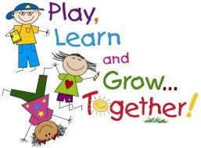 Welcome to Reception
We hope that you find this information useful. We’re sure your child will settle in with us and enjoy their new class. We will have a fun and exciting year together!
Please do not hesitate to contact us regarding any aspect or your child’s health, wellbeing and education. The best way to do this is after school at the gates or by contacting the school office to make an appointment to arrange a meeting or to talk over the phone.

Your Teachers  Class REG– Miss Gallagher  Class RSR - Miss Riley | Your Teaching Assistants  Class REG – Miss Cogger  Class RSR – Miss Farran  Reception classes - Miss Baidon

Coming into School
Staff will come to collect the children from the gate at 8.50am so everybody is in class by 9am. Our learning starts at 9.00am and it is really important your child is in the classroom for this time as it is a time when we are practising key skills. Your child hangs up their own coat, finds their name card in an area of the classroom and plays games to keep their skills sharp. Soon we will begin to use this morning jobs session for children to read with an adult, play phonics or maths games and practice other learning.

School Dinner
In Reception children are entitled to a free school dinner under the universal free school meals initiative. There are a variety of sandwich options currently available for children to choose from each day, these have been attached to this email for you to look at with your child. However, if your child brings a packed lunch into school please make sure it is filled with a balanced and healthy lunch For more information about healthy packed lunches please see the link below:
https://www.nhs.uk/change4life/recipes/healthier-lunchboxes

Reading Books
In Reception your child will be given a reading book and a reading record in a school book bag that we will provide. To support your child at home, please read every night for 10 minutes. This will have a big impact on not only their reading but also their writing, as they begin to recognise words and letters that they can use themselves. At home please practice pointing to each word saying them out loud with your child. You can also talk about the pictures and what is happening in the story. As they become more familiar with the simple repetitive sentences they will be able to point and read the book more independently. Children will read with an adult in school and so their reading book will need to be brought into school every day.

Uniform
It’s really important that your child comes into school EVERY day in full school uniform. This includes white t-shirt or shirt, grey school trousers, skirt or pinafore and blue school sweatshirt or cardigan. Shoes should be sensible school shoes with velcro fastenings or buckles and your child must be able to put them on and take them off themselves. All toys should be kept at home. Please write your child’s name clearly in all of their posessions.

PE
PE for both reception classes will take place on a Friday. Children will need to come into school wearing their PE kit which is a plain white T-shirt, black pair of shorts/leggings/tracksuit bottoms and some pumps/trainers. Please make sure earrings and any other jewellery is removed on PE days.

Behaviour
Children are expected to show respect to each other, to all adults and the school environment, both indoors and out. We have a clear behaviour system which encourages good choices in behaviour. There are a lot of rewards in place for Ravensbury children. The rules and behaviour systems are clearly displayed in all classrooms and around central parts of the school.
What are we learning about this term…?
Our topic this half term is called ‘Magical Me.’ During this topic we will be reading these stories that link to ourselves, our family, our bodies, autumn, harvest and being kind. We will also reread some of our favourite stories by the authors Julia Donaldson and Todd Parr. We will post pictures on the blog of our learning so you can share experiences with us.

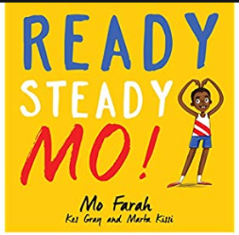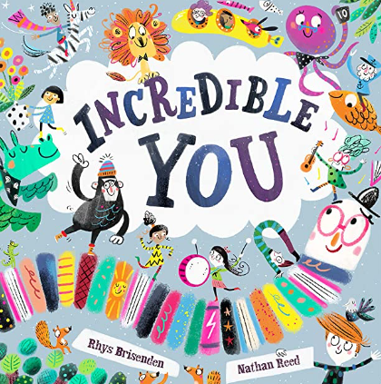

During this topic we will be exploring healthy bodies, autumn, healthy eating, drawing representations of people and objects and we will start to learn how to read and write simple words or captions or sentences. We will continue to develop routines and expectations of play across the classrooms. Children are currently being shown how to independently play with and to put away resources across both indoor classrooms and the outdoor classroom. In maths we will be exploring concepts of number through counting and labelling and looking at shapes around us. We will also be taking part in sports activities to link to our learning and we will celebrate harvest in class.

This year will be an important part of your child’s learning journey. We feel privileged to be able to walk with them and work in partnership with you to help your child achieve their potential as they complete the Early Years Foundation Stage. We hope you enjoy this year with us.

