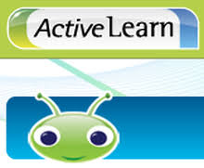

Dear Parents,
This week we are sending home details of another wonderful resource that you can use with your child online. Children in Year 1 should begin to use this resource as soon as they have reached Level 5 on Lexia.
Active Learn has resources linked to reading, phonics, spelling, punctuation and grammar. Children have been allocated a range of books linked to their reading and phonic ability. Once they read the books children will be able to complete activities linked to reading comprehension, phonics and spelling, punctuation and grammar. Children will receive coins which they can exchange for gifts for their own little world.
The logging in details are attached to this letter and to get started you must put the details in the following website:
https://www.pearsonactivelearn.com/app/Home
The username is your child’s first name and first letter of the last name. The password is set to read1 and you will need the school code ppsk.
Once you log in the screen will look like this: 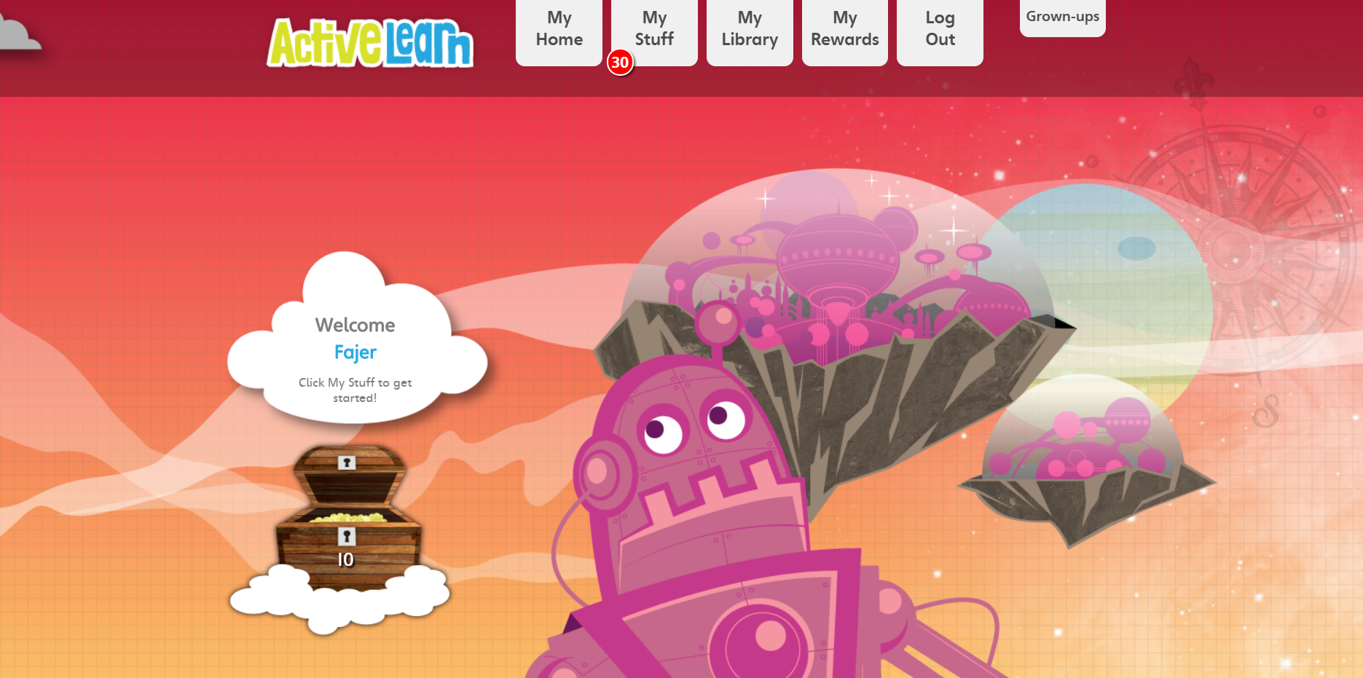
At the top you can access the books when you click on My Stuff. The red circle with the number in it shows how many books are available to your child.
If you have any queries please don’t hesitate to speak to your child’s teacher or email us on y1homelearning@ravensbury.manchester.sch.uk

Regards
Year 1 Team

