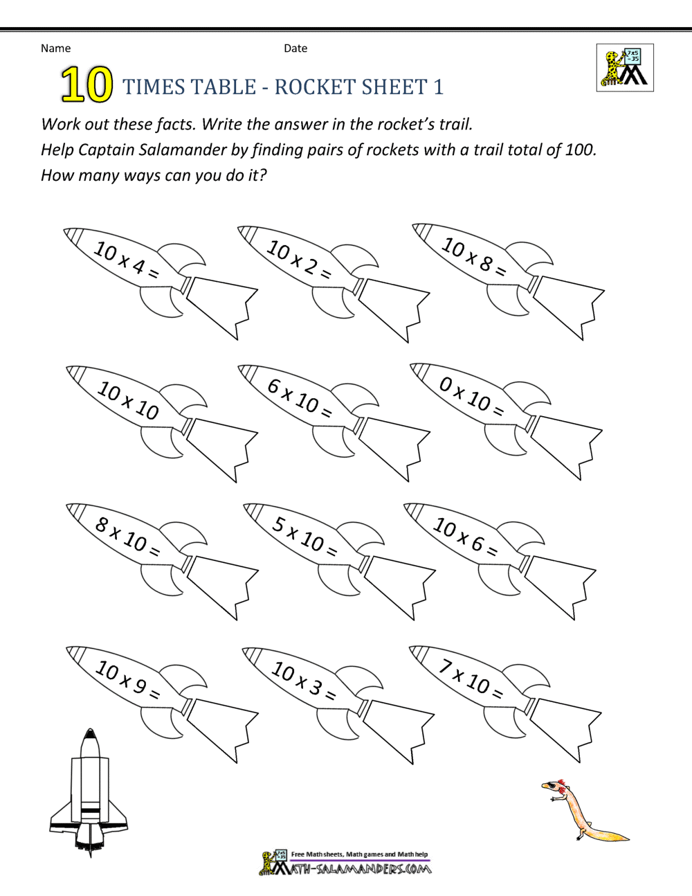

Spellings

wait

weight

sun

son

centre

century

certain

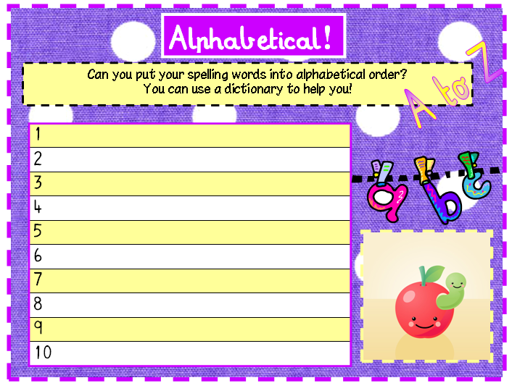

Can I count in multiples of 4 and 8?

4, _, 12, 16, _, _, 28

40, _, 32, _, _, 20

16, 24, _, 40, _, _

72, 64, _, _, 40, 32