Name: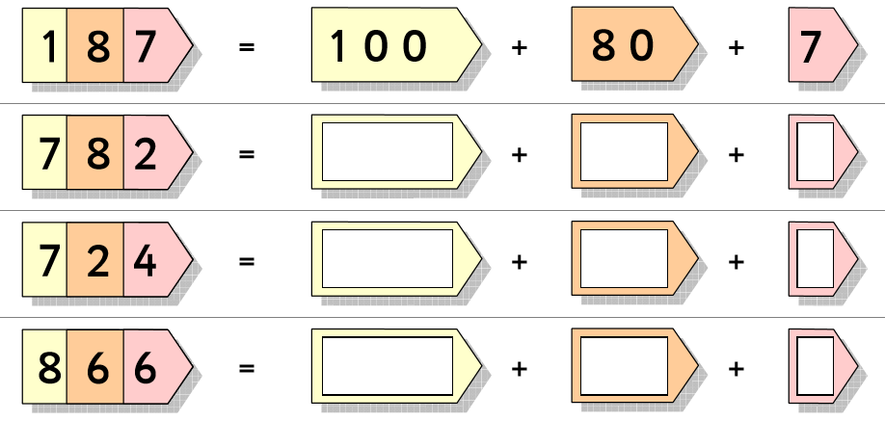
Example
673 = 70
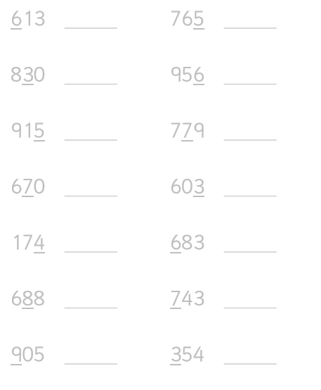
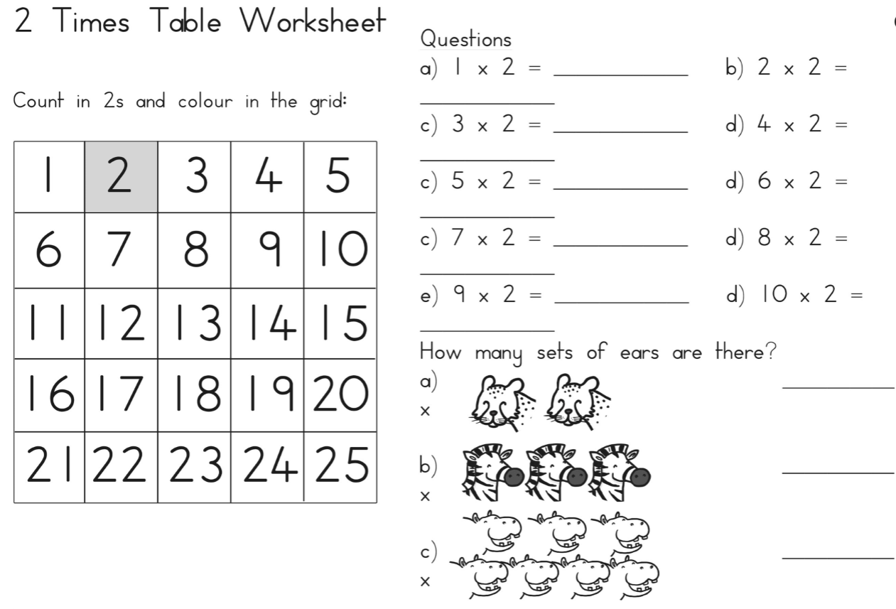
This week we are practise our 2 times tables.
Spellings
Prefixes – un and dis

unhappy
unlucky
unwell
dislike
disagree
disobey
disappear

