Parent’s guide to returning to school

At Ravensbury Community School our main focus is for the safety and welfare of our pupils, families and our staff.

We will do everything we can to make school the vibrant and exciting place it normal is but it will be a very different place, one which the children (and staff) might take a little while to get used to. But you can be assured that we will do our best to make the return to school as smooth as possible.

How are we going to keep your child safe in school?
Following guidance provided by the Department for Education school have put the following measures in place to reduce the risk of transmission and minimise the risk to pupils, staff and parents.

- To limit the contact between pupils as much as possible we will operate staggered start and finish times. These will range between 8.30 and 9.10 and 3.00 to 3.30 pm.
- Parents will only be allowed to enter the school premises to drop off and pick up their children. If you need to speak to your child’s teacher please phone the office to arrange a time to see them.
- Children will work in class bubbles
- Classroom spaces will look different.
- Children in KS1 and KS2 will sit at forward facing desks. All non-essential resources and furnishings will be removed.
- Children will be given their own stationery pack in a plastic wallet. It will contain all the equipment and resources they need. Reading books will be sent home in a book bag.
- Any shared resources like PE equipment and ICT equipment will be cleaned immediately after use.
- Lunchtimes and playtimes will be staggered.
- Children will not be allowed to bring anything in from home, except for a packed lunch in a disposal bag.
- Learning within classrooms will focus on core skills in the context of our Connected Curriculum.
- Children will be encouraged to wash their hands more regularly.
- Additional cleaning of areas during the day and a deep cleaning of classrooms once a week
- No whole school gatherings including assemblies
- If any child or member of staff presents with symptoms of coronavirus they will be sent home immediately and asked to self-isolate for 14 days. They will also be asked to access a test.
- If a child or staff member tests negative, they can return to school.
- If a child or staff member tests positive they will be asked to self-isolate for 7 days.
- If any child or member of staff tests positive the social bubble will be closed and people in that bubble will be advised to isolate for 14 days.
- Activities to focus on their physical health and mental wellbeing.

The main symptoms of coronavirus are
- high temperature – this means you feel hot to touch on your chest or back
- new, continuous cough – this means coughing a lot for more than an hour
- loss or change to your sense of smell or taste – this means you’ve noticed you cannot smell or taste anything, or things smell or taste different to normal

How to access a coronavirus test
- drive-through regional testing sites
- mobile testing units
- test kits delivered to your home
- hospital-based testing for NHS patients and staff
- school has a small number of home testing kits where it is difficult for you access one through the routes above
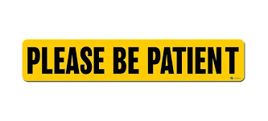
The health and safety of everyone at Ravensbury Community School is paramount so we ask that parents are patient when:
Dropping off and picking up children from school
When dropping children off, parents are asked to adhere to the staggered start time and wait along the pavement outside the allocated school entrance on the markings. Pupils will be asked to make their way to the allocated zone on the playground and line up on the markers provided where they will be met by their teacher.

When picking children up, parents are asked to adhere to the staggered finish times. Parents should queue along the pavement outside the allocated school entrance on the social distance markings. The children will line up in the allocated zone before being dismissed by their teacher one at a time. Please be patient.
Pupils in Y6 and Y1 should enter and exit through the gate on Stockholm Street at the allocated start and finish times.
Pupils in Y5 and Y2 should enter and exit through the multicourt gate at the allocated start and finish times.
Pupils in Y4, Y3 and Reception should enter and exit through the gate on Ravensbury Street at the allocated start and finish times.
Pupils in Nursery should enter and exit through the Nursery gate on Bank Street at the allocated start and finish times.
Don’t worry; Staff will be on hand to help.
Children should be dropped off and picked up by someone who lives in their household.
Uniform
Children should come to school in their uniform in September. Children should only bring in their PE kit on the days they have PE. It should then be taken home at the end of the day.

Lunchtime
At lunchtime the children will have 30 minutes to eat lunch in their classroom followed by 30 minutes outside to play in a zoned section of the playground. Each bubble will have a selection of equipment to play with which will be sanitised after use. We will continue encourage children to socially distance where possible

Parents need to know guide

At Ravensbury Community School our main focus is for the safety and welfare of our pupils, families and our staff.

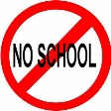 | Any child who is extremely critically vulnerable and has been advised to stay at home should not attend school.
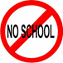 | If your child or a person in your house presents with symptoms of coronavirus they should not attend school
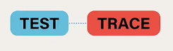 | If you are contacted by the NHS Test and Trace please inform the school immediately
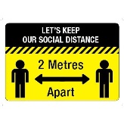 | Parents are asked to adhere to the social distancing measures in place around the school at all times for everyone’s safety.
1 adult | Only one parent should drop off and pick up children from the designated areas. This must be someone who lives in their household.
 | Parents should not gather and chat at the gate.
Please phone | Parents will not be allowed in the school building. If you need to speak to somebody in school then please phone school on 0161 223 0370.
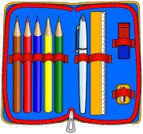 | Your child should not bring anything in from home; they will not need any stationary.
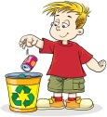 | If children bring in a packed lunch from home then we ask that it is put in a bag which can be thrown away.
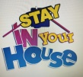 | Where ever possible children should stay in their own house. They should not go and play in anybody else’s house.
 | Children should come to school in their uniform. .
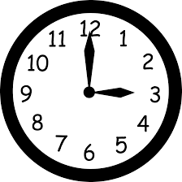 | Please make sure that you stick to the staggered drop off and pick up times.
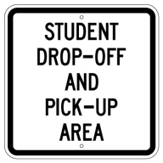  Y6 PUPIL DROP OFF AND PICK UP ZONE | Please drop off and pick up at the allocated zone for each yeargroup.

By working together and following these guidelines we can create a safe environment for the children.

