Ravensbury Community School
We create. We explore. We care. We soar.


Newsletter
In all my years of teaching I don’t think I have ever experienced anything as strange and upsetting as having to say goodbye to our pupils on the 20th March, not knowing when they would return. If anybody would have said to me at the beginning of the year that the children would be off school for 4 months I wouldn’t have believed them. It’s been a strange and uncertain time for us all and we all wanted the same thing; to have all of our children back in school. I am very proud of all the work everybody has done to support our children at this difficult time and have been amazed by the efforts you have made to support your child with their home learning; the messages and photographs you have sent into school have been a delight for staff to see.



Dates for your diary!

Wednesday 15th July: End of year reports
Parents will receive their child’s end of year school report via email

Staff Training Days!
Tuesday 1st September 2020 School is not open to children.
Wednesday 2nd September 2020 School is not open to children

Transition Days
Thursday 3rd September and Friday 4th September 2020. The children will get a chance to have some fun with their old teacher before joining their new class on 7th September.

School will close for the Summer holidays on Friday 17th July and will reopen on Thursday 3rd September 2020.

Look out for the welcome booklet
You child’s new teacher has made a transition booklet which will tell them a little bit about their new class and some of the things that they will be learning about next year. It will also give some ideas about what your child can do over Summer in readiness for the new academic year.

Dinner Money
From September the cost of dinners will remain the same at £2.30 a day which is £11.50 a week. All payments are to be made weekly via SIMS pay.

Welcome!
In September Mrs Chan, Miss Hamer and Miss Woodnett will join the Ravensbury team. Miss Powell and Mrs Rowson are both returning from maternity leave.

New additions to the Ravensbury Family
Mrs Ratcliffe had a little girl Orlaith Rose, Miss Marks had
a little boy Albie and Mrs Rowson had a little boy called
Ethan. All are doing well. Congratulations!

New Lockers
We have had new lockers installed. When the
children in KS1 and KS2 return in September they
will each have a locker to store their coat and PE kit
in. Large bulky bags will not fit in.

Building work
Work has now started on the housing development, on the
land opposite school, on Tartan Street. It is likely that there
will be increased traffic on the streets around the school, so
parents will need to take extra care when dropping off and
picking children up.

Breakfast Club

Unfortunately due to the current situation we are
unable to provide a breakfast club at this time. We
will review the situation again in September.


Goodbye and Good Luck
Miss Humphreys will be leaving us at the end of this term. We wish her all the very best for the future.



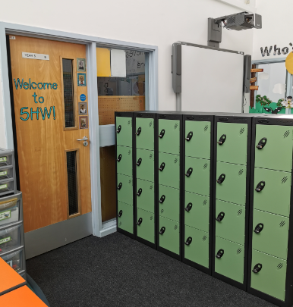

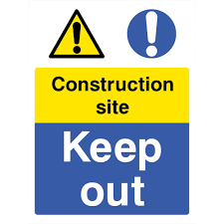



How did we get on with our key priorities this year?
Unfortunately due to the coronavirus pandemic we haven’t been able to complete all of the work we intended to do on our School Improvement Plan (SIP), so we will continue to work on them in 2020-2021.

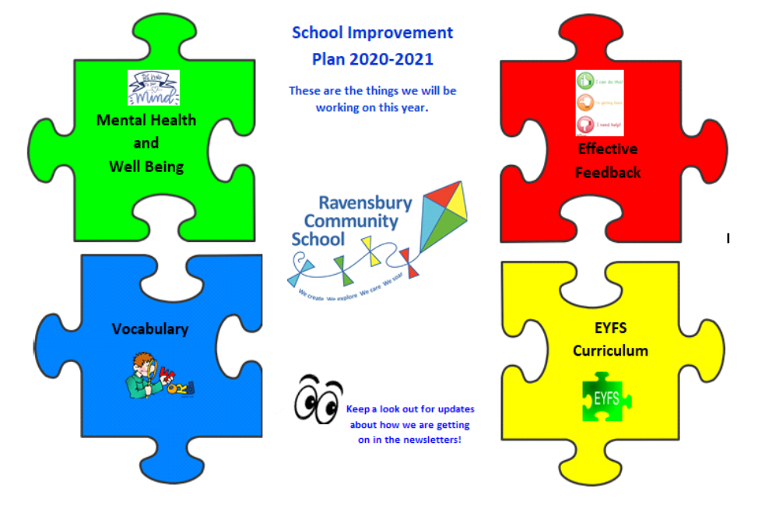
The pandemic has affected people’s health and wellbeing, as well as the children’s academic achievement. So we will work hard on our new key priority next year which will focus on ensuring the recovery from the impact covid19 has had.

School Uniform
Grey or black trousers/skirt/pinafore
White polo shirt
Royal blue sweatshirt/cardigan

PE Kit
Plain white T shirt (indoor and outdoor)
Black shorts (indoor and outdoor)
Black tracksuit bottoms/leggings (outdoor)
Trainers/pumps (outdoor)

School sweatshirts can be purchased from Panache Schoolwear in Droylsden, 90 Market St, Droylsden, Manchester M43 6DE.
Tel: 0161 301 5570




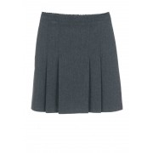

Reminder
Holidays in Term Time
We are not allowed to authorise holidays or trips during
term time. Parents need to be aware that if their child is
out of school for holidays or trips, legal action for
unauthorised absences is taken.

- Each parent/carer will receive a Penalty Notice of £120.00 for each child. This will be reduced to £60.00 if paid within 21 days of the fine being issued.
- Any such Penalty Notice or prosecution may relate to your child’s attendance record both prior to and subsequent to this letter.
- Each parent/carer may receive a court summons, which may lead to a criminal record and a fine.
- Your child is also at risk of losing their school place.
The Government have made it clear that they expect all pupils to return in September.

Medical/Dental Appointments
Parents are advised where possible to make appointments outside of the school day. Where this is not possible, pupils should attend school for part of the day and parents will be asked to show the appointment card.

Don’t forget to visit the school website to find out what the children have been learning. You can also now follow the school on Twitter.

  www.ravensbury.manchester.sch.uk | Our Twitter username is @RavensburyComm1
2019-2020 has been a strange year for Ravensbury. Here’s hoping that 2020-2021 will be a better one!
We hope you all enjoy the summer break and we look forward to seeing you all in September

Best Wishes
Mrs Hughes
Headteacher






