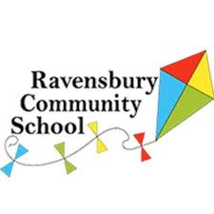
Parent’s Meeting-September 2020
Dear Parent/Carers,
Thank you for accepting a place at Ravensbury Community School. We are delighted that you want your child to attend our school in September 2020.
As part of the admission process we would like you to attend a parent’s meeting. This meeting will be delivered by Mrs Hughes, the Headteacher. It is important that you attend this meeting as it will give you an opportunity to meet the Reception team and find out more information about the school. The meeting will be held in the hall and parents will be asked to enter and exit the building via the multi court gate entrance. Please do not worry a member of staff will be at the school gate to help you.
As a school we feel it is important that we have an opportunity to meet with you in person. Due to the Covid Pandemic we ask that only 1 parent per household attends and unfortunately we won’t be able to accommodate children. The meeting will take place on Friday 4th September at 2pm.
We look forward to meeting you in September!
Kind Regards
Miss Wolfenden
Assistant Headteacher

