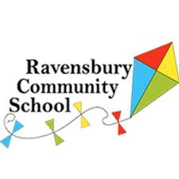

Reception Transition start dates
Dear Parent/Carers,
To make the transition into reception as successful as possible all children will start the reception class on a part time basis. Due to the Covid pandemic the school have had to change the way in which the children enter and leave school, in line with government guidance. Mrs Hughes, the Headteacher regularly updates families on the Government guidance on the school website. Please have a look and keep yourselves updated. The most recent information will be shared with you at the parents meeting on Friday 4th September 2020 at 2.00pm.
The children will start school on Monday 7th September 2020. They will come into school at the times listed below.
Monday 7th September- 9.00am- 11.30am
Tuesday 8th September- 9.00am-12.30pm
Wednesday 9th September – 9.00- 2.00pm
If your child is settled and copes with the school day then the class teacher will extend his/her hours to full time. However, if your child finds the school day difficult the part time hours will remain until they are ready to access full time education. Please do not worry! Each child is different and will be ready in their own time!
If you feel that you or your child might need more support with this process and you feel that you might need to speak to a member of staff then contact school via this email transition@ravensbury.manchester.sch.uk
Kind Regards
Miss Wolfenden
Assistant Headteacher

