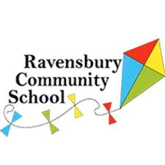
Parent’s Meeting-September 2020
Dear Parent/Carers,
Thank you for accepting a place at Ravensbury Community School. We are delighted that you want your child to attend our school in September 2020.
As part of the admission process we would like you to attend a parent’s meeting. This meeting will be delivered by Mrs Hughes, the Headteacher. It is important that you attend this meeting as it will give you an opportunity to meet the Nursery team and find out more information about the school. The meeting will be held in the hall and parents will be asked to enter and exit the building via the multi court gate entrance. Please do not worry a member of staff will be at the school gate to help you.
Due to the Covid 19 Pandemic the government have advised that we do not hold large gatherings in school. As a school we feel it is important that we have an opportunity to meet with you in person so we are going to hold smaller meetings- no more than 13 families at one time. We ask that only 1 parent per household attends and unfortunately we won’t be able to accommodate children. To support the organisation of this we have placed families into a meeting bubble. We ask that you stay in your allocated bubble as we will be unable to have any additional people in the hall. Please look in your transition pack to find out which bubble you are in!

Bubble 1 – We will meet with you on Tuesday 8th September at 10.00am
Bubble 2 – We will meet with you on Tuesday 8th September at 2.00pm
Bubble 3 – We will meet with you on Wednesday 9th September at 10.00am
Bubble 4 – We will meet with you on Wednesday 9th September at 2.00pm
We look forward to meeting you in September!
Miss Wolfenden
Assistant Headteacher

