Can you choose the correct word to fill the missing word in each sentence?

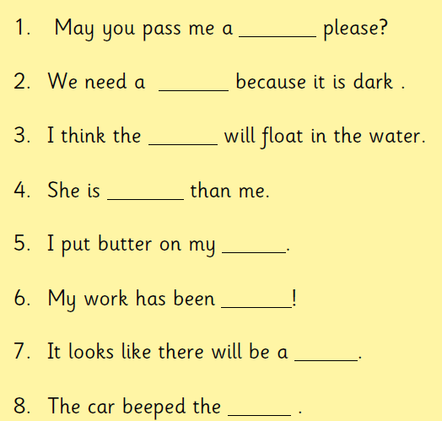

fork | horn | storm | torn
torch | cork | shorter | corn

