OO Word Sort
oo as in book (short sound) | oo as in moon (long sound)  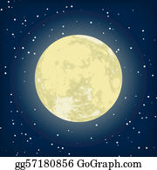

food | good | look | roof | cook
foot | noon | hook | room | zoo

