Can you label the pictures with the short ‘oo’ words?
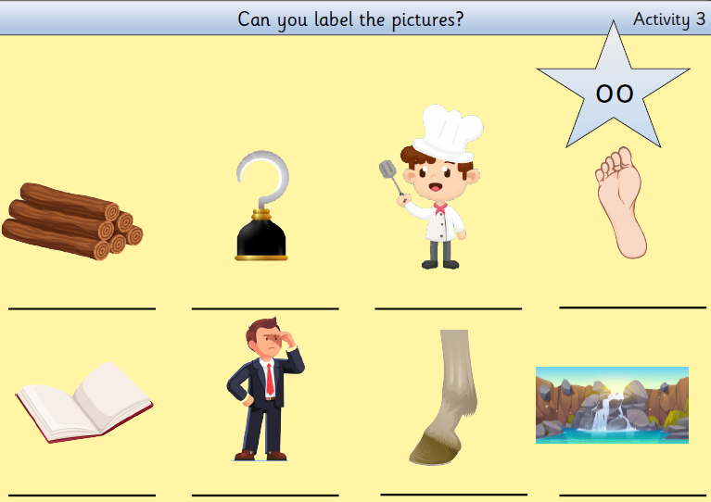

Can you choose the correct word from the table to put in each sentence?
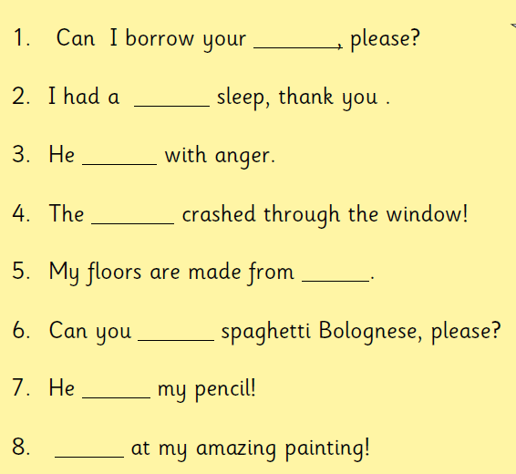

book | good | shook | football
wood | cook | took | look

