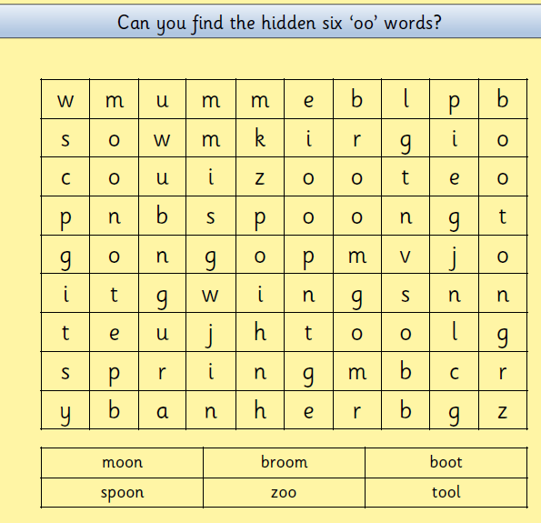

Picture Hunt and Write it!!!
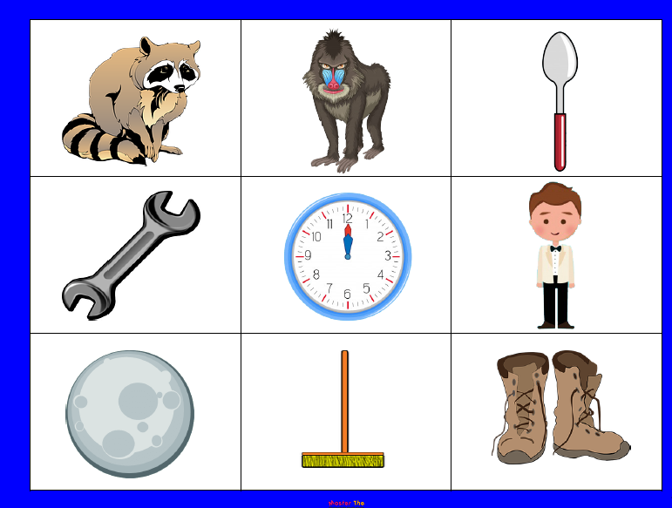

Print and cut out these pictures and ask a grown up to hide them in your garden or a room in your house. If you don’t have a printer you can draw the pictures. Put some music on and have a dance. When the music stops find a picture and write the word on a piece of paper.

