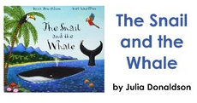
Read the words below. Can you match the words that rhyme from the story…?

snail | flock | sea | dock | bright
soot | foot | fins | snail | song
rock | night | whale | rock | free
sail | long | foot | put | grins

