How many words can you read…? Play quick write using these words.

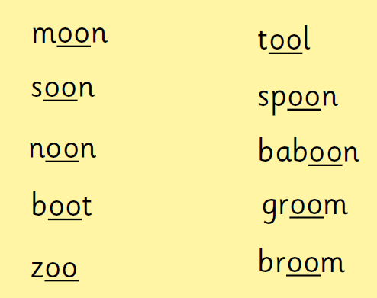

How many words can you think of in 1 minute with the long ‘oo’ sound?

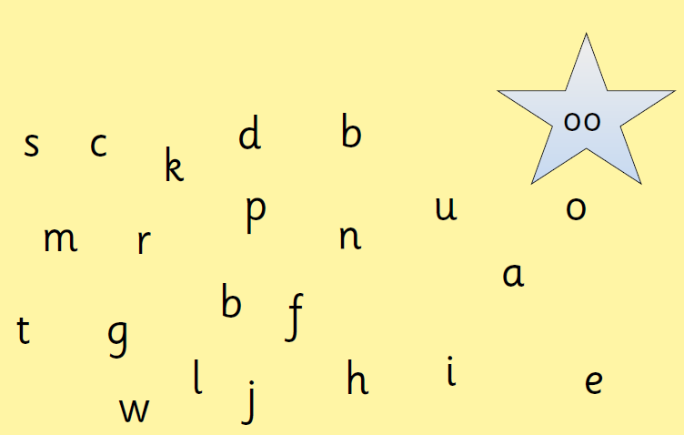

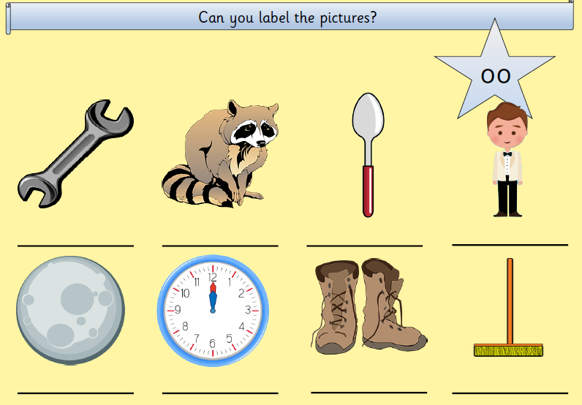

Now pick three words and put them in sentences…

