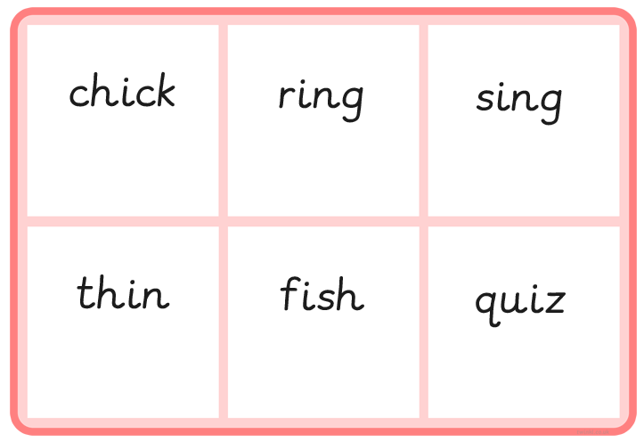

chick | sing
thin | them
fish | chin
ring | quick
quiz | shed

