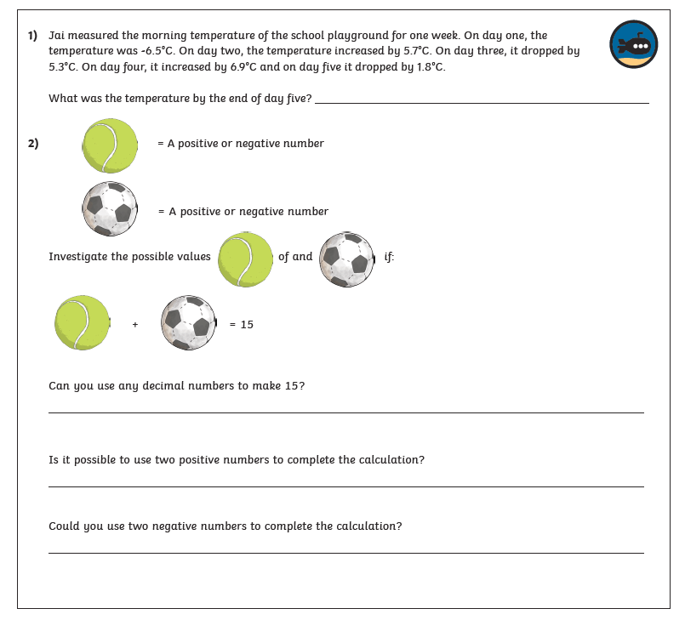
Negative Numbers – 23.04.2020

