Maths
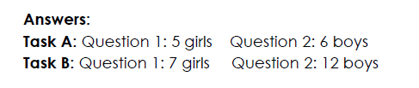
Sentence of the day
Many flowers are brightly coloured to attract insects and other animals to them.

