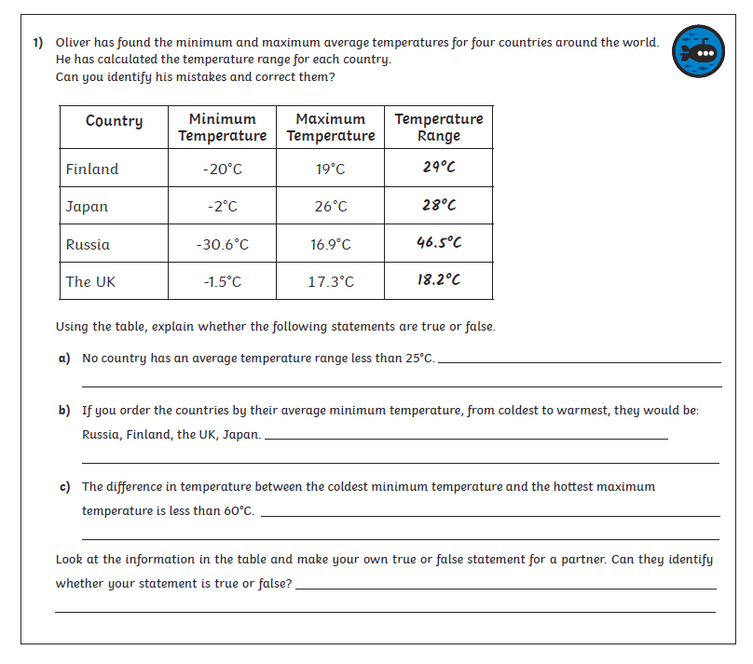
Challenge Sheet – 22.04.2020

