Maths
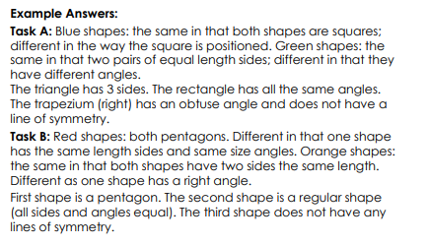
Sentence of the day
boudicca's army charged forwards, pulled out their spears and grunted loudly.

