





**Holiday Homework**

**Things have been tricky over the past few weeks so over the Easter holidays it is really important to have FUN! So we would like you to complete as many of the activities below as you can. Tick off each activity when you have done it and send some photos to your yeargroup email.**

   

Create a card for an adult you love to show them you care

Find an unusual place to read a book

Play a board game

Clean your room

 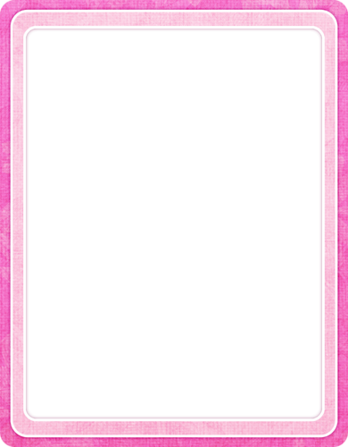 

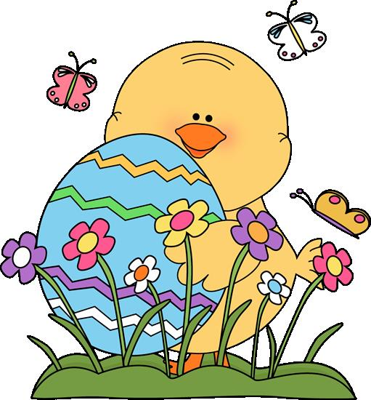

Laugh till your cheeks hurt.

Do something nice for someone.

Do something nice for someone.

   

Write a letter to your teacher and send it to school

Do a random act of kindness for someone in your family.

Learn a new skill

Go on a scavenger hunt round your house and find an object beginning with each letter of the alphabet

   



Watch a favourite movie with your family

How many words can you make out of the word ‘Ravensbury’

Eat an Easter egg

Paint a rainbow and put in in your window

