Friday 3rd April Challenges
How many challenges will you be able to complete today…?
- Make your own number line on the washing line. | - Can you create a game outside? Use the resources around you. | - Can you make a weather station? After all April is the month when it is supposed to rain a lot!!Get a container or pot and measure the rain. | - Senses challenge – what can you see, hear, smell, feel and taste…? | - Go on a minibeast hunt in your garden. What creatures will you find…?  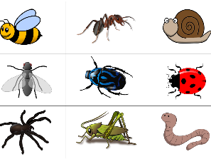
- Fill a small tray with soil in the garden. Can you create a small garden for some of your toys? | - Can you make a tower using things that you find? You might use sticks, stones, bricks or pasta. Who will make the tallest tower in your house? | - Can you make numbers and letters or your name using things in or out of your house? You may want to use twigs, stones, pasta, cars, toys… | - Can you create a picture of your family that you live with in your house? You may want to draw, paint or make it using things in the garden. | - Write your tricky words, sounds, numbers or name using chalk. You may want to use large sheets of paper, a wall in your garden or the pavement outside.

Good Luck!!!

