Dear Parents/Carers

Replacement Free School Meal Scheme

Please only use this link as it will take you to where you need to apply for the Free School Meal payments.
https://secure.manchester.gov.uk/info/500361/coronavirus/7938/coronavirus_-_benefits_and_money/4

Ensure that you read the eligibility on the webpage before applying.
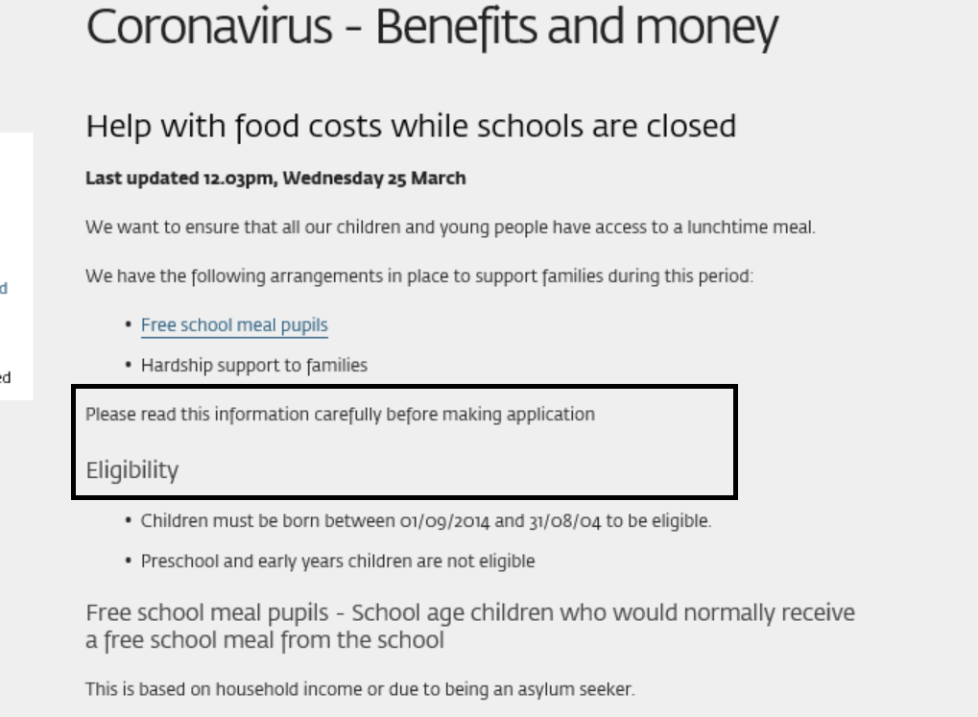

Only if you are eligible; click on the link (Council’s Welfare Provision Scheme)
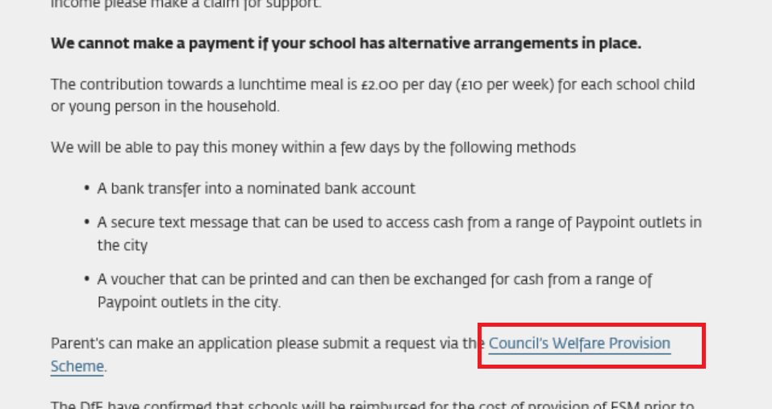
Scroll to the bottom of the page and click on Apply for a Cash Grant.
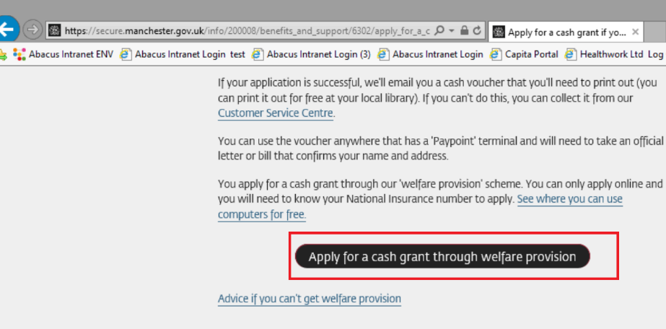
Hope the above helps and thank you for your patience in this matter.

Regards

