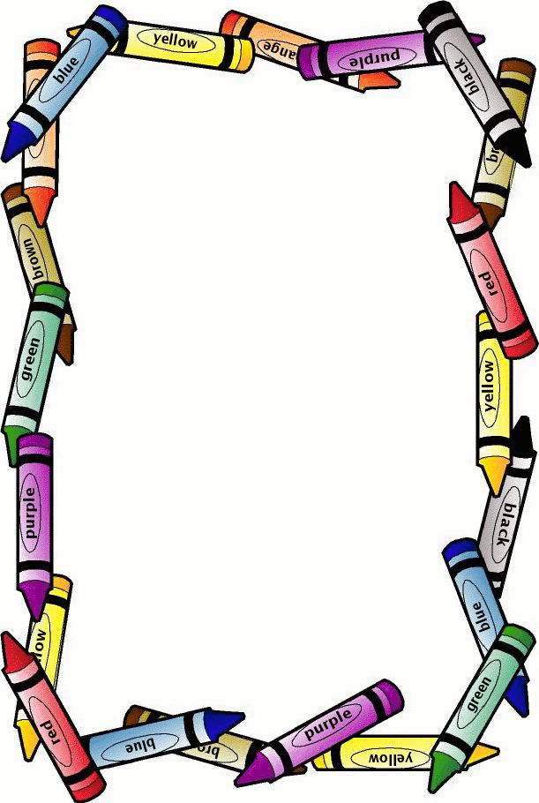

Dear Year 6,

I know that many of you are really sad today at the thought that this might be your last day here at Ravensbury. The teachers are sad too but whatever happens, I promise you, you will have a graduation assembly and a leavers party, we are just not sure when.

The news is really scary at the moment and it is ok to feel scared but it won’t always be like this. Every single one of you is already famous and are part of history. Children in years to come will learn about the pandemic known as the coronavirus, just as you have learnt about the holocaust and World War II.

We know that you will be disappointed not to take your SATs but don’t worry we know you very well and we will share this information with your high school. All your hard work won’t go to waste! Remember Ravensbury learners are the best!!! We want you to continue to make us proud over the forthcoming weeks; complete the home learning packs. Keep in touch; tweet us and send pictures to your year group email. The year 6 team will be checking in with you on a regular basis. You can’t get rid of us that easily.

I want you to stay positive and remember that everybody at Ravensbury is thinking of you. I am not going to say goodbye, I’m going to say ‘au revoir’ which means goodbye until we meet again.

Take care and we hopefully we will see you soon.

Best wishes,