Dear Parent / Carer

Important information regarding student attendance – from Monday 23 March 2020

Firstly, thank you for the very supportive approach that you have taken during these exceptionally challenging times. Whilst we are formally closed from Monday 23 March onwards, we will continue to support your child, both academically and pastorally and our school remains at the heart of our community.

Special opening from Monday 23 March.

The most recent scientific advice on how to further limit the spread of COVID-19 is clear. If children can safely stay at home, they should, to limit the chance of the virus spreading.

The government have asked us to remain open only for children of critical workers and vulnerable children where we can.

Key workers
At midnight, the government published a list of those parent / carers who are entitled to send their child to school. The link below provides specific details.

https://www.gov.uk/government/publications/coronavirus-covid-19-maintaining-educational-provision/guidance-for-schools-colleges-and-local-authorities-on-maintaining-educational-provision

The list includes the following; health and social care, education and childcare, key public services, local and national government, food and other necessary goods, public safety and security, transport, utilities, communication and financial services.

We are grateful to all of these key workers who are looking after us all. In return, our staff team are also going to offer provision for your child / children. It is critical to note, however, that this provision should only be taken up if there are no other alternatives (see guidance).

If you think that your job is classified as a key worker, you have no other alternatives and you wish to take up this provision, please contact us by telephone 0n 0161 223 0370. You may be asked to provide us with some evidence.

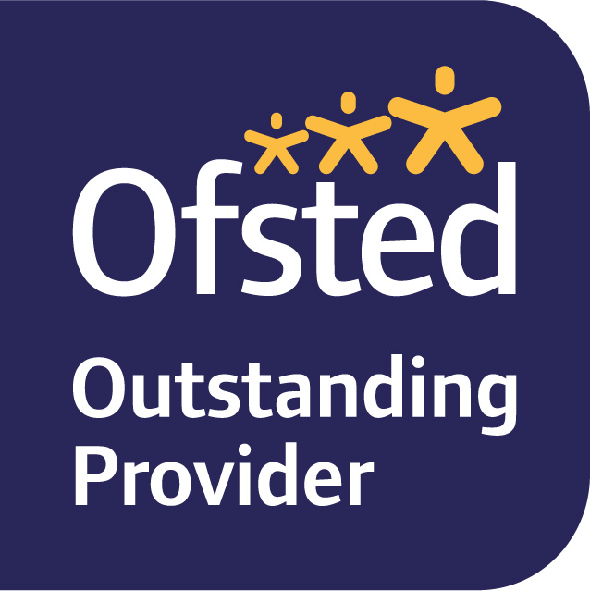
Specialist Support Provision
Those children with safeguarding and welfare needs, including those children on child in need plans, on child protection plans, ‘looked after’ children, young carers and those with Education Health and Care plans are also able to attend school if they wish. This is an offer to parents and there is no requirement for parents / carers to send their children to school if they do not wish to.

Free School Meals
If your child is entitled to free school meals, our school will provide £20.00 for the next two weeks until the City Council can set up a payment scheme.

You have already had payment until Friday 3rd April after this date you will need to apply to the City Council who are also setting up a scheme to help with food costs for families who are facing additional financial challenges due to the Covid 19 virus.

To qualify your family must be Manchester residents or supported by the Homelessness Service. The criteria is:

- Children and young people who meet the criteria for free school meals (where the school have not got other arrangements in place);
- Children and young people who are classed as an asylum seeker; and
- Children and young people whose family has been hardest hit by the recent issues and may be waiting for benefits to be assessed or have a gap in their income due to being laid off etc.

The contribution towards a lunchtime meal is £1.75 per day (£8.75 per week) for each child or young person in the household.

The Council will be able to pay this money within a few days by the following methods
- A bank transfer into a nominated bank account
- A secure text message that can be used to access cash from a range of Paypoint outlets in the city
- A voucher that can be printed and can then be exchanged for cash from a range of Paypoint outlets in the city.

To make an application please submit a request via the Council’s Welfare Provision Scheme

https://lwa.financialassessments.co.uk/OnlineApplication/(S(1w2yi5bjmzswqq0vvciplvtv))/Introduction.aspx?form=LWAFULL&time=637202318515007959,1584635052308

Ravensbury Community School will be closed to the majority of students from Monday 23rd March, but we are in no way closed in terms of our ongoing care, support and kindness.

With Best Wishes

Mrs Hughes

