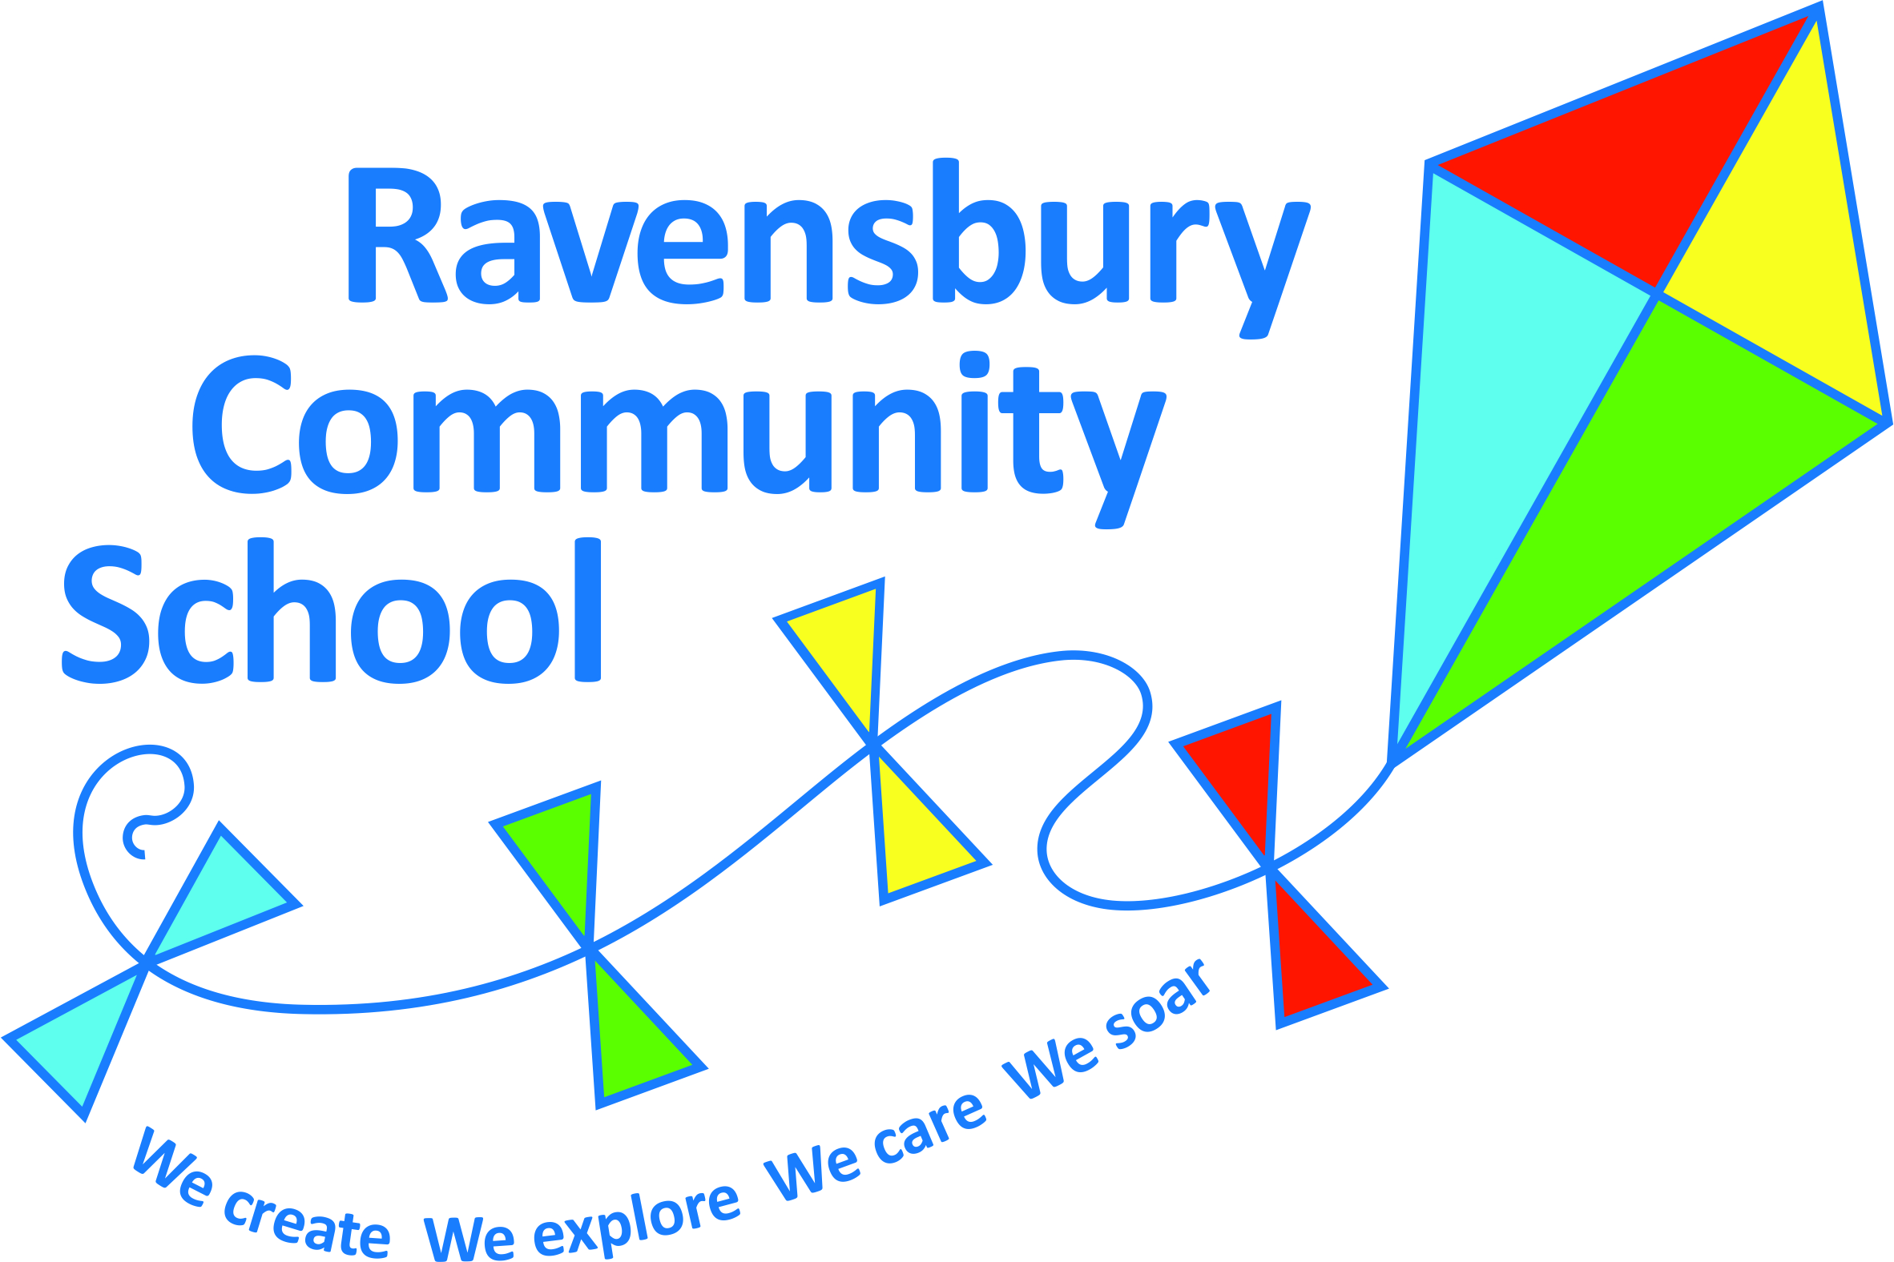
Ravensbury Community School
Y2 Connected Curriculum Overview

Year 2 | Key Texts – link to English | History | Geography | Art | Design Technology | Experience and Golden Question
Autumn 1  Why can’t we just eat chocolate? | Whiffy Wilson : The Wolf who Wouldn’t Wash  The Disgusting Sandwich |  | Human and Physical Geography  Use aerial photographs and plan perspectives to recognise human and physical features, use and construct basic symbols and a key.  Describe the location of features and routes on a map (builds on compass points Y1).  What places do we have in our local area to help us keep fit? | Printing  Use vegetables to create print blocks |  | If you are healthy, are you happy?
Autumn 2  Could the Great Fire of London happen in Clayton? | Vlad and the Great Fire of London  Extracts from Samuel Pepys’ Diary  The great Fire of London information sources | The lives of significant people & events from the past: Know where people and events they study fit within a chronological framework. Use a wide vocabulary of everyday historical terms. They should ask and answer questions choosing and using parts of stories and other sources to show that they know and understand key features of events.  Understand some of the ways which we find out about the past and identify different ways in which it is represented. Make links to historical periods children will study in KS2 -The Tudors.  Great fire of London  Samuel Pepys |  |  | Structures and mechanical systems  Children to follow the Design Technology process of: Design, Make and evaluate.  Explore and use mechanisms (lever and slider) to create a Tudor House (Great Fire of London).  Use cardboard and paper ‘mock ups’ to design and evaluate the most effective lever and sliders. | What would you do if you saw a house on fire?
Spring 1  Why do some animals live in cold places and others in hot? | Scott of the Antarctic  The Great Explorer | The lives of significant people & events from the past who has contributed to national achievements: Exploration and Discovery.  Link to PSHE & Year 2 Victorians  Robert Falcon Scott | Location Knowledge  Use world maps atlases and globes to identify countries, continents and oceans. Name and locate 7 continents and 5 oceans.  Identify the location of hot/cold areas of the world in relation to the Equator and N/S Poles; compare with seasonal and daily weather patterns in the UK (following on from Y1).  Locate polar regions and compare climate. | Painting  Antarctic Animals  To develop a range of art and design techniques in line, shape, form and space. |  | If you were on an Antarctic exploration, who or what would you miss from home?
Spring 2  Where would you prefer to live; Wuhan or Manchester? | The Great Race  Non-fiction texts about Wuhan and China |  | Place Knowledge  Similarities/differences of small area of UK & non- European country: China  Geographical skills and Fieldwork  Use of maps, globes, atlas.  Human & physical geography  Weather and climate in Contrasting locality UK and China  Use basic geographical vocabulary to refer to key physical features: sea, ocean, river, season, vegetation, weather, continent and country.  Human features: City, town, village. |  | Textiles  Children to follow the Design Technology process of: Design, Make and evaluate.  Investigate & evaluate products  Make a Chinese dancing dragon according to traditional characteristics developed through research | What aspects of Chinese culture do we have in the UK?
Summer 1  Do we recycle enough? | Recycling  How effective is Recycling ? |  | Geographical skills and Fieldwork  Compass directions  Map work – symbols – based around the park –local area. |  | Textiles/Nutrition  Use reclaimed materials to make new products – choosing a suitable material – Juice box wallets, CD sun catchers.  Design an appealing snack based on minimising food waste e.g. using up half a packet of biscuits, old cereal, end of a chocolate bar etc.  (Link to environmental issues) | What would happen if we stopped recycling?
Summer 2  What did Queen Victoria do for us? | Queen Victoria | Identify similarities and differences between the ways of life in different time periods. Ask and answer questions choosing and using parts of stories and other sources to show that they know and understand key features of events. Make links to historical periods children will study in KS2.  Leisure Time now and in the Victorian period  Queen Victoria |  | Drawing  Portraits and sculpture (using clay)  Describe the differenced and similarities between portraiture and sculpture. Compare the work of:  JMW Turner (portrait painting)  Francis John Williamson (sculptures of QV) |  | Would you like to have been royalty in the Victorian era?

