Year 1 – Autumn 2
Topic Question | Core Text | Visits/Visitors
Could the Three Little Pigs use a better material to build their houses? | 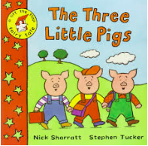 | Visit from a builder
Driver and Enhancer |  | Experience  (linked to Global Citizenship skills)
Geography and DT |  | Building competition
Key Learning  Geography | Key Learning  DT | Golden Question  (linked to British Values and SMSC)
- Map making using own keys and symbols  - Use compass directions NSEW  - Name and locate the 4 countries and capitals within the UK | - Design and make houses for the Three Little Pigs – making them stronger, stiffer and more stable. | If you could use any material what would you build your house from and why?
Key Vocabulary
near, far, left, right, NSEW, country, capital city, compass, map, direction, compass point, design, evaluate, test, build
How to Help at Home
Talk to your child about the materials different objects are made from.

