Activities to help counting

**PLACE VALUE**

Take a handful of objects, guess more or less than 10?

Then count (touch and move)

Count out the 10’s and then the units

Use **place value cards** to make the number they have made

**CONSERVATION OF 5**

When adding 2 numbers above 5 (i.e. 8) – children will usually count 5 on one hand, then 2 on the other – then start **right back at the beginning** to count 5 and then 2.

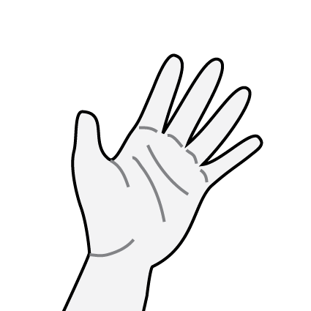

The trick is to ask them how many fingers they have? (5)

**Have you lost any**? If you know you have 5, then just **count on!**

**Problems in counting**

* Children sometimes count out of sequence (1,3,2,5)
* Children may count 1 – 5 but not know that the last number is the total
* 1 to 1 match - say

12345 when there are only 3 objects present

(i.e.) skim over the objects chanting count – but not matching!

**MULTI-SENSORY COUNTING**

Take a handful of

* Dried beans
* Pasta shapes
* Conkers
* Buttons

**Guess** how many are there (more or less than 10?

**Count** (touch and move) – to know that the last number is the total

**DICE COUNTING**

Throw a dice – count out that total using multisensory objects

Find the number on a laminated 100 square, circle with a WB pen

Repeat a number of times

(Repeat with 2 dice to make a TU number- reverse number (4 & 2 – 42 or 24

Find on a 100 square and mark

Practise writing numbers -Order numbers on a WB

**COUNTING CARDS**

* Match the picture total to a number
* Match the number to the same total but different picture
* Match picture total to a dice throw
* Match the picture to graphic dice
* Say one more/less
* Order amounts etc.

**HIGHER / LOWER**

Use a pack of playing cards

Take out the King, Queen, Jack and Ace

Order the pack from smallest to biggest

Shuffle thoroughly

Then play HIGHER – OR LOWER

**READING AND ORDERING**

Use place value cards (tens and units only)

Turn over & read a ten & unit to make a 2 digit number

Read the number and write on a WB - Repeat five times - Write them on post it’s and put in order

Count them out and put into piles