What Can I Do to Help with Maths?

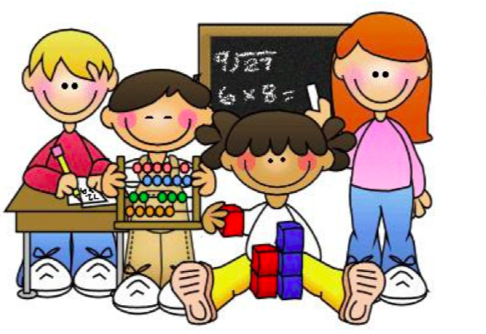

A guide for Year 1 Parents

Why do children need to be secure with mental strategies?

It builds up confidence and helps towards written Maths

Developing skills slowly means that children can retain them in long term memory

They need basic facts at their fingertips to solve a range of puzzles and problems

It speeds up time working things out, making longer calculations easier to complete

It prepares children for life! Having a good knowledge of mental methods means adding costs in shops, working out times and distances, budgeting and being financially independent in the future

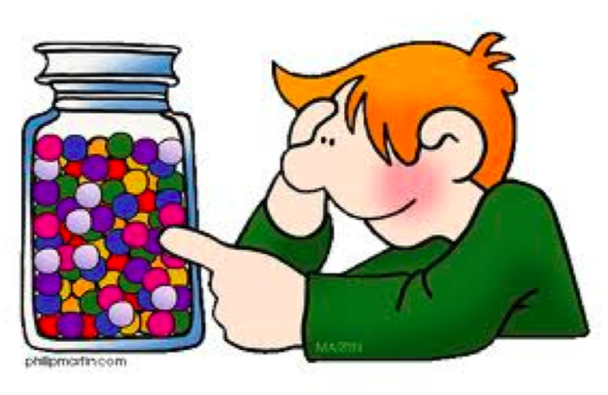
Year 1 objectives

I can say one more/one less than a number to 50
Counting forwards and backwards in rote, then stopping to test next number.
Finding numbers on a hundred square
Playing who am I – give children clues “it’s after 12 but before 14, it’s an odd number”

I can recall addition and subtraction facts to 10.
Sing the number bond song with your child.
Roll a die - what do I need to add to this number to get to 10?
Play Zing Zong Bong – tap your knees twice as you say zing and zong. On bong, show a number below 10 on your fingers. Your child has to say the number you need to add to that to get to 10. Take turns.

I can partition two-digit numbers into tens and units.
Try to get your child to do it orally – how many tens in 23? How many units?
Emphasise that there are two lots of ten and three units, so the number partitions into 20 and 3.
Lots of online games, such as –
http://www.ictgames.com/ dinoplacevalue.html http://www.ictgames.com/sharknumbers.html

I can identify odd and even numbers.
Give your child a pile of socks. Have we got an odd or even number? Well, to find out, can we pair them all up? If there’s one left on its own, it’s odd.
Rote singing - 0, 2, 4, 6, 8, even numbers are just great. 1, 3, 5, 7, 9 I love odd numbers all of the time.
Play an odd and even race.

I can count on in tens from 0 to 100.
Use a hundred square, encouraging them to go down the hundred square to add on ten.
Play splat online - Splat a number and ask your child to find 10 more by moving down on the hundred square.
Use a dice, roll a number ask them to write the number and add on ten.

I can count back in tens to 0.
Choose a number up to 100, write the number and show them how the units stay the same.
Ten less than 24 = 14.
When going down the stairs count back in tens.
I can count on in 2’s from 0.
Count in twos whilst going up the stairs.
Count pairs of shoes, or pairs of socks.

I can count back in twos to 0.
Chant in 2’s backwards.
Consolidate 2 less than, by going back two steps.

Recall doubles to double ten. Recall halves to ten.

Number Games
Board Games
Snakes and Ladders
Dominoes
Playing card games e.g. snap doubles
Dice Games
Sharing sweets, objects etc.

