11th June 2021
Dear Parents/carers,
I hope you all enjoyed the half term break and managed to get out and enjoy the sunshine. Unfortunately it looks like the COVID-19 restrictions will be with us a little while longer, I know that this news is disappointing as we were looking forward to an end of term free of restrictions but hang on in there we will get through this together.
You will have seen in the news that Greater Manchester has now moved to an Enhanced Response Area due to the rise of COVID-19 cases in the region. In Manchester, the COVID-19 infection rates are rapidly increasing and in the past week, rates have practically doubled which is very worrying.
It is essential that we all do what we can to stop the spread of the virus and to keep everyone safe.
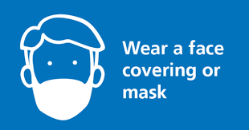 | Parents are asked to wear a face covering when dropping off and picking up children, unless they are exempt.
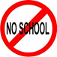 | If your child or a person in your house presents with symptoms of coronavirus they should not attend school.
 | If your child or someone in the household goes for a covid-19 test, the child should not come back into school until the test results have been received.
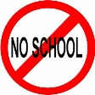 | If your child has been in contact with someone who has coronavirus they need to isolate for 10 days and access a PCR coronavirus test.
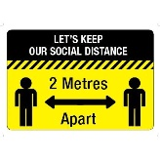 | Parents are asked to adhere to the 2 metre social distancing measures in place around the school at all times for everyone’s safety.

By working together and following these guidelines we can create a safe environment for the children.

Take care and stay safe

Mrs Hughes
Headteacher
