Winter Water Safety

Following the tragic incident which occurred in Solihull over the weekend, please share this information about the dangers of playing on frozen water with your children.

Stay safe in winter – the dangers of frozen waters

In winter, children and pets are particularly at risk when tempted to play on the ice formed on open water, and adults can find themselves at risk in attempting to save them.

Taking a nice walk in cold weather with your family, friends or dogs in tow can be really refreshing, just make sure you know some simple tips on how to stay safe in winter.

Areas with frozen lakes, ponds, canals and reservoirs can be beautiful places to visit during the winter months but all too often many people risk their lives by venturing onto frozen water. Here are some useful tips to help you know what to do in an emergency.

Our Tips
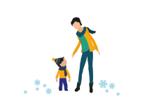

Teach children not to go on the ice
Teach children not to go onto the ice under any circumstances.
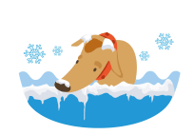

Don’t go on the ice to rescue a dog
Don’t go onto ice or into the water to rescue a dog, move to somewhere that the dog will be able to climb out and call them towards you.
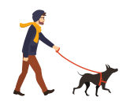

Keep dogs on their leads
Keep dogs on their leads when near ice and don’t throw sticks or toys onto the ice.

Only use well lit areas
Time your walks to make the most of the daylight; if you need to walk in the evening only use well-lit areas or take a route not alongside water.

Keep back from the edge
When walking alongside water keep back from the edge.

What to do if you fall through the ice:

- Keep calm and shout for ‘help’
- Spread your arms across the surface of the ice in front of you
- If the ice is strong enough, kick your legs to slide onto the ice
- Lie flat and pull yourself towards the bank
- If the ice breaks, work your way to the bank-breaking the ice in front of you anyway
- If you cannot climb out, wait for help and keep as still as possible. Press your arms by your side and keep your legs together. Keep your head clear of the water
- Once you are safe, go to hospital immediately for a check up

What to do if you see someone fall through the ice:

- Shout for assistance and phone the emergency services – call 999 or 112
- Do not walk or climb onto the ice to attempt a rescue
- Shout to the casualty to ‘keep still’ and offer reassurance to keep them calm
- Try and reach them from the bank using a rope, pole, tree branch, clothing tied together or anything else which can extend your reach
- When reaching from the bank, lie down to avoid being pulled onto the ice
- If you cannot reach them, slide something which floats, such as a plastic bottle or football, across the ice for them to hold onto to stay afloat whilst help is on the way
- If the casualty is too far away, do not attempt to rescue them. Wait for the emergency services while calming and reassuring the casualty

What to do after the casualty has been rescued from the ice:

- Make sure the ambulance is on its way
- Lay the casualty flat, check for normal breathing and begin resuscitation if necessary
- Prevent them from getting colder by covering them with warm clothing, blankets etc.
- Get them out of the cold under cover or create some shelter around them
- Until the casualty is in a warm place, do not undress them
- Do not rub their skin, do not apply hot water bottles and do not give an alcoholic drink
- Keep them wrapped up so they warm up gradually

