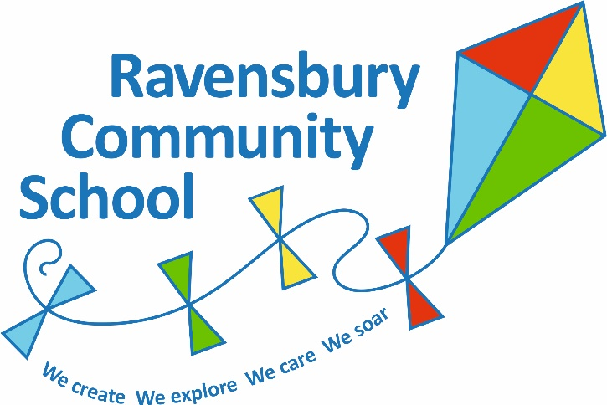

Community Cohesion Policy

There is a duty for schools to promote community cohesion under the Education and Inspections Act 2006.

At Ravensbury Community school we work in partnership with our community and other organisations to ensure we do all we can to promote and establish strong, respectful relationships that enhance the outcomes for children and their families. Community cohesion lies at the heart of what we do.

Introduction
The curriculum at Ravensbury Community School aims to promote the spiritual, moral, cultural, mental and physical development of our pupils and of society and prepare our pupils for the opportunities, responsibilities and experiences of later life.

As migration and economic change alter the shape of our increasingly diverse local communities, it is more important than ever that all schools play a full part in promoting community cohesion. Our school has a thriving, cohesive community, but it also has a vital part to play in building a more cohesive society.

Every school - whatever its intake and wherever it is located - is responsible for educating children and young people who will live and work in a country which is diverse in terms of culture, faith, ethnicity and social backgrounds. This policy supports the work of, and is supported by, other school policies, such as Race Equality, Equal Opportunities, Disability Equality Duty, and also our developing policy on Gender Equality. We have a duty to eliminate unlawful discrimination, and to promote equality of opportunity and good relationships between people of different groups.

Ravensbury Community School has good links with other schools and organisations to give our pupils the opportunity to mix with and learn with, from and about those from different backgrounds

We believe that it is the duty of all schools to address issues of ‘how we live together’ and ‘dealing with difference’ however controversial and difficult they might sometimes seem.
In order to prepare our learners for living in a diverse and cohesive society, we strive to work in
partnership to:
• Encourage the development of a secure sense of their own identity, as individuals and
within the many communities to which they belong.
• Encourage open and positive attitudes towards diversity and the development of the
skills, understanding and confidence to challenge prejudice, discrimination and
stereotyping.
• Support the children in becoming active citizens who recognise their rights and
responsibilities, enabling them to make informed judgements.
• Ensure equality of opportunity, and remove barriers to access and eliminate
discrimination.
• Ensure they receive a broad and balanced education and succeed in reaching their
potential.
• Provide opportunities for positive interaction with people from a variety of backgrounds in
the local and wider community.

What is community cohesion?
By community cohesion, we mean working towards a society in which there is a common vision and sense of belonging by all communities; a society in which the diversity of people’s backgrounds and circumstances is appreciated and valued; a society in which similar life opportunities are available to all; and a society in which strong and positive relationships exist and continue to be developed in the workplace, in schools and in the wider community.

Community from a school’s perspective
For schools, the term ‘community’ has a number of meanings including:

  - The school community – the pupils it serves, their families and the school’s staff;
  - The community within which the school is located – the school in its geographical community and the people who live or work in that area;
  - The community of Britain - all schools are by definition part of this community;
  - The global community– formed by EU and international links.

In addition, Ravensbury Community School has created further communities with the local cluster of schools and through links with high schools.

What can we do to promote cohesion?
All schools, whatever the mix of pupils they serve, are responsible for equipping those pupils to live and thrive alongside people from many different backgrounds. However schools that are driven by divisions are less likely to perform well.

For some schools with diverse pupil populations, existing activities and work aimed at supporting pupils from different ethnic or socioeconomic backgrounds to learn with, from and about each other, will already be contributing towards community cohesion. For other schools where the pupil population is less diverse or predominantly of one faith,
socioeconomic or ethnic group more will need to be done to provide opportunities for interaction between pupils from different backgrounds.
Just as each school is different, each school’s contribution to community cohesion will be different and will need to develop by reflecting:

    - the nature of the school’s population – whether it serves pupils drawn predominantly from one or a small number of faiths, ethnic or socio-economic groups or from a broader cross-section of the population, or whether it selects by ability from across a wider area.
    - The location of the school – for instance whether it serves a rural or urban area and the level of ethnic, faith and socio-economic diversity in that are

In the light of the new duty we need to consider how different aspects of our work already support integration and community harmony; to take stock of what has worked well so far. We also need to consider where there may be scope to improve their existing work through a more explicit focus on the impact of their activities on community cohesion.

In addition, schools will want to consider the duty to promote well-being as some of the work and activities that support community cohesion can also contribute towards the Every Child Matters outcomes of ‘making a positive contribution’, ‘enjoy and achieve’ and ‘achieving economic well-being’

We consider what activities already take place within the school and what might be arranged in cooperation with other schools. The schools’ contribution to community cohesion can be grouped under the three following headings:

    - Teaching, learning and curriculum – to teach pupils to understand others, to promote British values and to value diversity, to promote awareness of human rights and of the responsibility to uphold and defend them, and to develop the skills of participation and responsible action.
    - Equality and excellence – to ensure equal opportunities for all to succeed at the highest level possible, removing barriers to access and participation in learning and wider activities and eliminating variations in outcomes for different groups.
    - Engagement and ethos – to provide a means for children, young people and their families to interact with people from different backgrounds and build positive relations, including links with different schools and communities locally, across the country and internationally.

Teaching, learning and curriculum
Our teaching and the curriculum provision supports high standards of attainment, promotes
common values, and helps students understand and value the diversity that surrounds them recognising similarities and appreciating different cultures, faiths, ethnicities and socio-economic backgrounds. Lessons provide opportunities for students to develop their understanding and empathy; Helping them to value differences and challenge prejudice and stereotyping. The wider curriculum helps to promote an awareness of the rights of individuals and also to develop the skills of participation and responsible action.

We ensure:
    - Lessons across the curriculum promote British values and help pupils to value differences and to challenge prejudice and stereotyping – for example, opportunities in PHSE lessons for pupils to discuss issues of identity and diversity and what it means ‘to live together in the UK’.
    - Curriculum based activities develop pupils’ understanding of community and diversity is enriched through visits and meetings with members of different communities.
    - Support for pupils where English is an additional language (EAL) to enable them to achieve at the highest possible level in English.
    - An effective voice and involvement of pupils in the governance and organisation of the school in a way that teaches them to participate in and make a difference in school, in their local community and beyond.

Equity and excellence
In school, there is a focus on securing high standards of attainment for all pupils ensuring that they are treated with respect. Barriers to learning and wider activities are removed eliminating a variance in outcomes for different groups of pupils to ensure all pupils achieve their full potential. Effective procedures exist to deal with prejudice, bullying and harassment. The school’s admission arrangements promote community cohesion and social equality. Our tracking and monitoring systems enable us to evaluate progress of different groups and to minimise the risk of underachievement by members of any particular group. It also allows us to identify whether pupils from particular groups are more likely to be excluded or disciplined than others. An appropriate behaviour policy in place to deal with this.

Engagement and ethos
We provide different opportunities for young people and their families to interact with people from
different backgrounds and build positive relationships. We seek to strengthen the ways in which we work in partnership with other schools. We look either locally or further afield and the means of developing the relationship may be through the internet. Sharing facilities also provides a means for pupils to interact, as do opportunities for meaningful intercultural activities such as sport and drama. The School Council and Eco-Team, which involves the children in the decision making and organisation of the school, teaches the children the importance of participation and making a difference to the school, local community and beyond
Good partnership activities with the local and wider community might include:
    - Working together with community representatives, for example through mentoring schemes or bringing community representatives into school to work with the pupils, ensuring that the pupil voice is heard and able to effect change.
    - Community representatives and parents being part of the schools Governing body.
    - Maintaining strong links and multi-agency working between the school and other local agencies, such as the youth support service, the police and children services and health professionals to support the learners’ education.
    - Engagement with parents through coffee mornings, parent evenings, parent and child courses and our Parent Support Officer/Caseworker.
    - Provision of extended services, and in particular bringing parents together from different backgrounds through parenting and family support and community use of facilities for activities that take place out of school hours, including adult and family learning, Maths and English classes run by Manchester Adult Education.
    - Engagement with parents through an open door ethos, parents’ evening, curriculum meetings, class assemblies, festivals and other celebrations is considered a priority at the school.

Teaching, learning & the curriculum | Equity & excellence | Engagement & ethos
Teaching and curriculum provision (Religious Education, PHSCE, collective worship and assemblies that supports high standards of attainment, promotes common values, and builds pupils' understanding of the diversity that surrounds them | Effective approaches are in place to deal with incident of prejudice, bullying and harassment e.g. monitoring our incident reports, giving feedback to the Governors and following clear school procedures | Strong links and multi-agency working between the school and other local agencies, such as the youth support service, the police and social care and health professionals
Lessons across the curriculum that promote common values and help pupils to value differences and challenge prejudice and stereotyping | Reasonable adjustments made to allow all pupils with additional needs to access learning. | Community events e.g. music performances, drama performances, Summer production, celebration events
Support for pupils for whom English is an additional language to enable them to achieve at the highest possible level in English | Equality policy and objectives | Musical performances
Houses; each house supports a local charity | Barrier free school | Experiences as part of the connected curriculum
Musical performances Collective worship / reflection | Anti-bullying policy | Inter house competitions
Transition work and link work undertaken with high schools | Safeguarding policy | Providing EAL courses for parents
Booster classes, Easter school | Breakfast club/Early bird learning club | Sports Day
Close links and visits from and to local church | First aid training/medical training for staff
Visits to local places of worship | Close links with local private nurseries
Connected curriculum | Close links with local primary schools
Educational visits | School Council
National events; Black history month, | Peer Mediators
Jigsaw PHSE curriculum | Links with health professionals and outside agencies
British values | Healthy Schools Silver Award
Support national charity events; Red Nose Day, Jeans for Genes day, Sport Relief | Working towards Green Flag award
 | Eco School award
 | Inter school Sporting festivals

