Ravensbury Community School

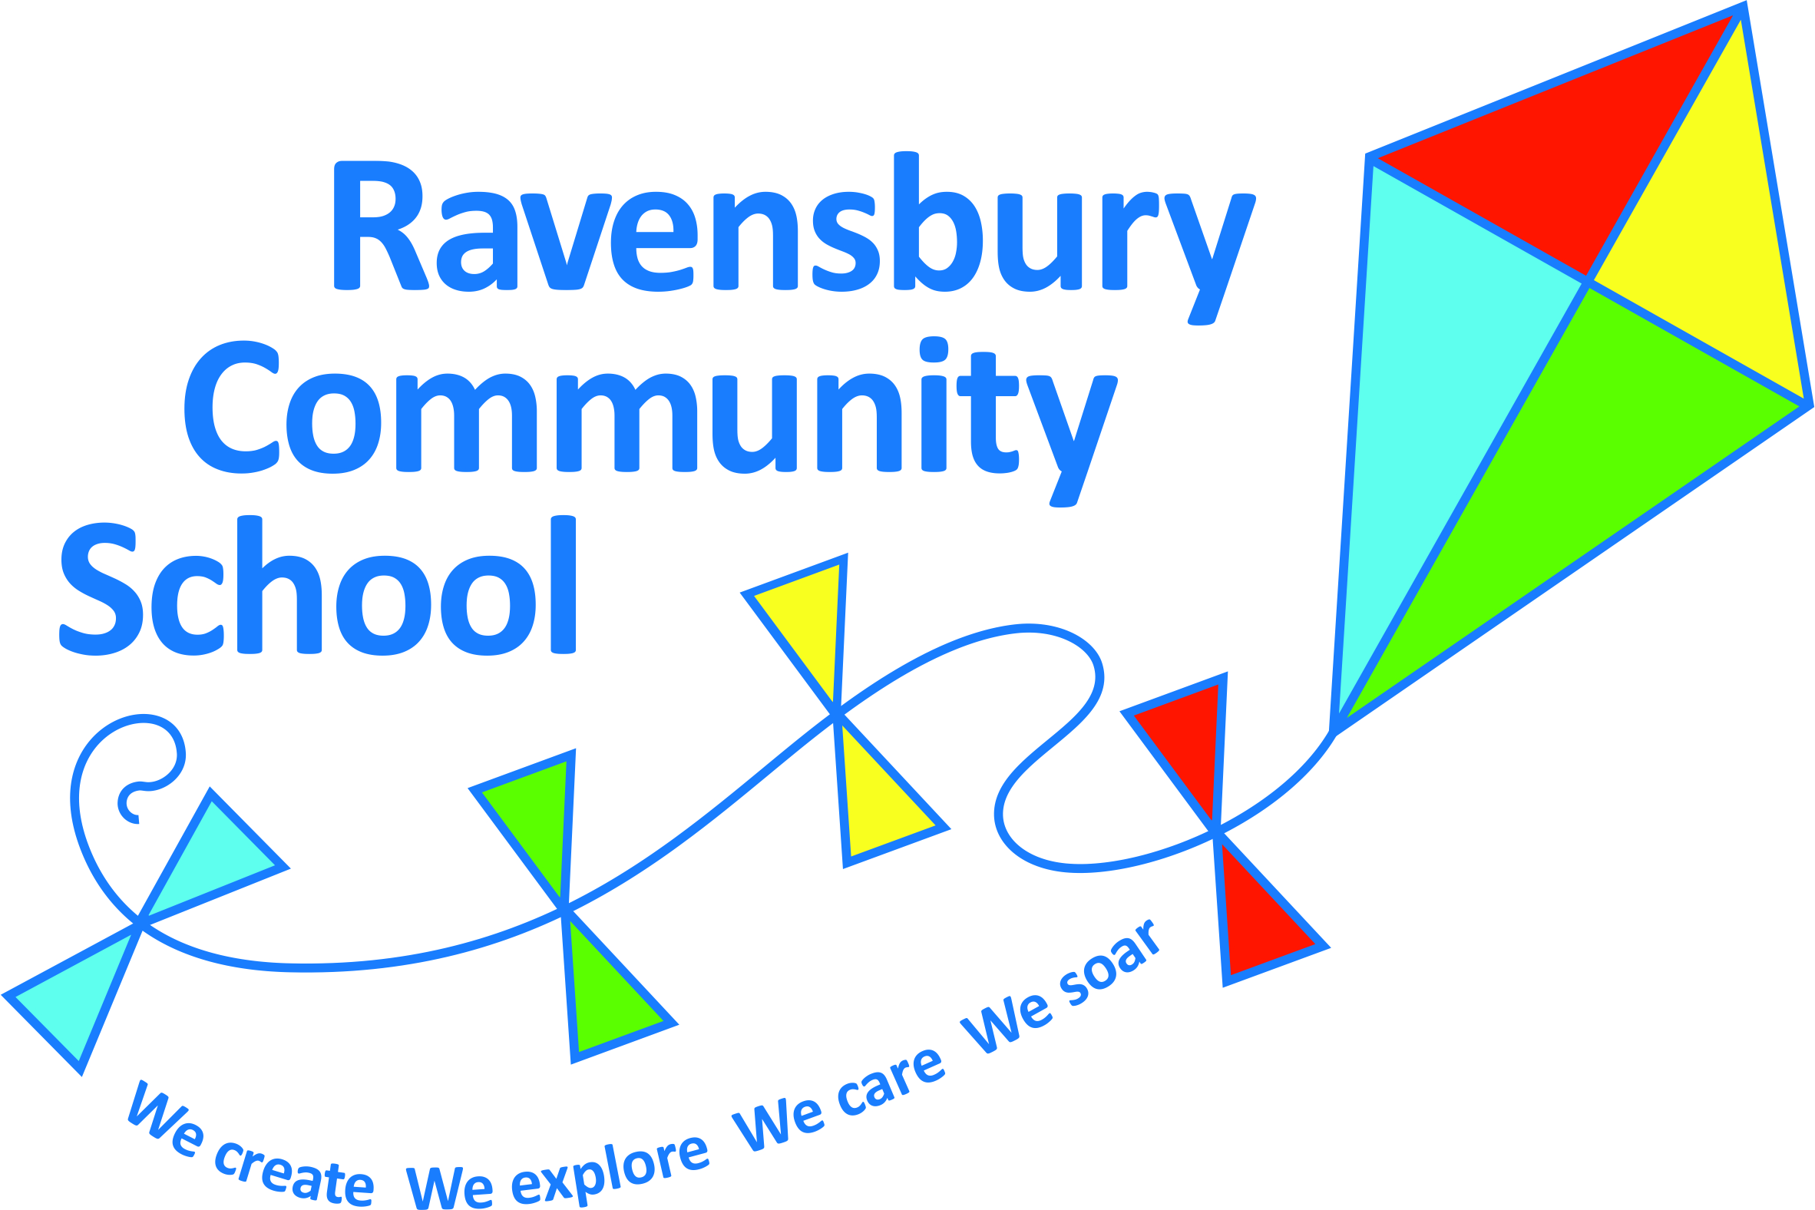

Remote/Blended Learning Policy

Document Title: Remote/Blended Learning Policy

Document Owner: Ravensbury Community School

Review Date: September 2023

This policy will be reviewed annually unless an incident or new legislation or guidance suggest the need for an interim review.

Review Date | Changes Made | By Whom
October 2020 |  | Headteacher

Ravensbury Community School
Remote/Blended Learning Policy
Remote Learning Introduction
To be fully prepared in the event of future closures, partial closures or isolation of bubbles, Ravensbury Community School has carefully considered, consulted on and developed this policy for remote learning. The overarching goal is to enable pupils to access high-quality teaching and learning even when they are unable to attend school. The policy outlines how teachers and other school staff will work to provide remote learning, whether they are delivering blended learning through the provision of both in-school and online lessons, or only accessing online home learning.

In the event of long term closure or part-time attendance, staff at Ravensbury Community School will continue to provide a broad and balanced curriculum and support for our pupils, using in-school teaching, remote learning and/or a combination of both. Depending on the circumstances, learning will be conducted using in-school teaching and learning, educational packs of resources and the pupil area on our website (School Spider). This will allow staff to have daily discussions with pupils, as well as ensuring that the needs of all pupils are met. Teachers will organise learning in a way which does not overwhelm or concern our pupils. Teaching and learning will be tailored, changed and updated as time progresses, in-line with the latest guidance, allowing for replication of classroom activity to the best of our ability.

Aims
The aims of this policy are in line with current government guidance on schools reopening from September 2020. The specific aims are:
- to plan and outline how and when the remote learning policy will be implemented in our school.
- to support all pupils in their access to high- quality remote teaching and learning.
- to provide a clear remote learning strategy, including how and when learning should be assigned remotely, how it will be communicated, how pupils will submit work and how they will receive feedback on submitted work;
- to anticipate, identify and address any concerns associated with remote learning, relating to safeguarding, data protection, and health and safety;
- to make staff roles and responsibilities clear in relation to remote learning;
- to declare the software and online tools approved for use by us to support remote learning;
- to declare how and when we will support the delivery of home learning by staff, including the possible provision of hardware.

Remote Learning Strategy (see appendix A)
The systems and procedures outlined in this remote learning policy will come into effect under any of the following circumstances:
- a pupil, groups of pupils, class or bubble are required to self-isolate at home, including quarantining after returning from overseas.
- in the implementation of a local area lockdown and subsequent school closure
- if a member of staff is required to self-isolate but able to work from home
Systems and digital workspaces
We will use the secure pupil area on our website to upload work. Pupils will be give individual usernames and login details to access the pupil area. Pupils who do not have access to technology; devices or internet will be allowed to loan it from school. Parents will be asked to sign a loan agreement accepting responsibly for the equipment and agree to it being used by the named pupil/s for completing school work only. If parents do not wish to loan equipment then a learning pack will be provided. The pupil area in School Spider has bad word and bullying filters, any attempt to post either will result in an alert being sent to the class teacher and the website administrator.
Flexibility
We realise that the circumstances that cause our school to adopt a ‘blended learning’ approach will affect families in a number of ways. In our planning and expectations we are aware of the need for flexibility: parents may be trying to work from home and so access to technology as a family may be limited; teachers may be trying to manage their home situation and the learning of their own children, or the effective planning for both in-school and remote learning opportunities; systems may not always function as they should. An understanding of, and willingness to adapt to, these difficulties on all sides is essential for success.

Expectations
In the case of long term closure, we believe that it is in the best interests of our pupils that we continue to provide structured support to the best of our ability. Bearing in mind the need for flexibility. That said, the work that pupils engage in during a period of closure, or as part of the ‘blended learning’ approach, will be part of our current planning and so cannot be considered as optional. We will expect all pupils to complete the home learning tasks set in the allocated time frame. If families are having any difficulties with this then they should discuss it with their child’s class teacher.

Lesson sequences, content and planning
Teachers will plan and deliver the same teaching sequence remotely as they would in school, as outlined on the teaching and learning overviews which are on the website. Lesson sequences will build on prior knowledge, skills and understanding as well as providing pupils with opportunities to practice and consolidate skills.

Online lessons during ‘bubble’ closures
Teachers will provide daily lessons online, through pre-recorded videos which will outline the days learning as well as providing videos which model the concepts and skills being taught. Teachers will organise daily learning into separate sessions to provide a framework for pupils so that they do not become overwhelmed. Teachers will use a range of different approaches which are content and age appropriate; use of Apps, websites, quizzes etc.

Online lessons if a member of staff is required to self-isolate but able to work from home
If teachers are self-isolating but are able to work from home they will teach the class through daily live lessons. The teacher will be supported by one/two TAs who will oversee the lessons being taught and support the pupil’s to access the lesson. The children will access the same lessons as they would as if the teacher was in school. Teachers will adhere to the guidance set out in the ‘Guide to Safer Live Lessons’ published by National Online Safety.

Communication and visibility
School staff will use the functions in the pupil area on School Spider to communicate with pupils on a daily basis. Pupils will be able to interact with their peers during online lessons using the discussion feature on School Spider. Pupils will only be able to interact with pupils at Ravensbury Community School. If a pupil posts and offensive word in a blog then the post is automatically taken down and an alert will flash up saying ‘This has been sent to be checked by your teacher’.

Providing pupils with feedback
Pupils will be expected to complete the learning set each day either on screen or in book. They will receive individual daily feedback the following day via the marking and feedback feature on School Spider.

Roles and responsibilities
Teaching staff will…
- Place a significant emphasis on pastoral development
- Prepare daily resources to meet the needs of each child. (hard copy where requested)
- Share teaching and learning activities with their class through School Spider
- Continue providing work and support in line with current planning that is
already in place throughout the school.
- Be aware that learning remotely will be more difficult, so tasks will be shortened and supported in smaller steps to allow for this.
- Ensure daily contact with pupils, either face-to-face or through School Spider.
- Reply to messages, set work and give feedback on learning/activities during normal working hours 9.00am-3.30pm (where practically possible)
- Have an understanding of the circumstances may affect families in a number of ways.
- Inform the Headteacher if unwell to ensure that work and keeping in touch with parents is covered by another staff member
Non-teaching Staff will…
- Support class teacher in preparation of support packs/activities.
- Have access to ICT devices (loaned from school).
- Give feedback on learning/activities during normal working hours 9.00am-3.30pm (where practically possible)
- Inform the Headteacher (if unwell).
- Support, where necessary, individual/small groups of pupils by providing tailored
- activities which can either be used in school or when learning at home.
- Have access through Google Drive to support remote learning.
- Ensure their communications have been shared with the class teacher and/or SENCO.

Pupils will...
- Adhere to all guidelines as directed by staff and comply with the expectations set.
- Be assured that wellbeing is at the forefront of our thoughts and they should take regular breaks, get fresh air, exercise and maintain a balance between online engagement and offline activities.
- Complete any tasks prepared for home learning as set on on the weekly timetable.
- Try to to keep up-to-date with daily teaching and learning, either in-school or on School Spider
- Only send messages and queries that are in relation to tasks set by the teacher or in response to questions the teacher may ask them directly.
- Only access the material shared by their teacher and will ask for parental permission to use technology for anything beyond that.
- Read daily, either independently or with an adult when possible, including Lexia

Parents will...
- Support their child’s learning to the best of their ability, in-line with the Home school Agreement
- Ensure that any equipment loaned from school will be used for the sole purpose of pupils completing online remote learning.
- Ensure their child engages activities and completes all learning set by the teacher (either hard copy or digital) within the allocated time. Class teachers will alert SLT if children are not assessing home learning.
- Know they can continue to contact their class teacher as normal through the pupil area on School Spider or by contacting the school office, if they require support of any kind.
- Check their child’s completed work each day and encourage the progress that is being made.
- Be mindful of mental well-being of both themselves and their child and encourage their
child to take regular breaks, play games, get fresh air and relax when working at home.

Software and Hardware
Software
All Staff have remote access to Google Drive and are able to access this from home. They will share files via this function.

Hardware in school
All school staff have access to a laptop and/or Ipad to access Google Drive and the schools website. All teaching staff have log in details to access the school website remotely if working from home.

Pupils’ access to technology at home
Pupils who do not have access to technology at home; devices or internet will be able to loan this from school. Parents will be asked to sign a loan agreement accepting responsibly for the equipment and agree to it being used by the named pupil/s for completing school work only. If parents do not wish to loan equipment then a learning pack will be provided.

Security and online safety
Pupils will be taught about being good digital citizens. They will be taught about E-safety through their computing lessons and what information is appropriate/inappropriate to share online. Parents will be signposted to information about online safety and have access to training sessions on setting parental controls and how to keep their child safe on line. Chromebooks loaned from school will be linked to the schools filtering system.
https://www.nspcc.org.uk/keeping-children-safe/online-safety/
https://www.thinkuknow.co.uk/
https://www.internetmatters.org/

Promoting good digital citizenship
Pupils will be taught about what it means to be a good digital citizen. A good digital citizen is someone who understands the rights and responsibilities that come with being online and someone who uses technology in a positive way. https://www.commonsense.org/education/videos/we-the-digital-citizens

Screen time and being active
Pupils will have access to a range of timetabled activities which encourage them to limit the amount of screen time to approximately 2hrs 6-11 year olds, 1hr 3-5 year olds. Pupils will be taught about screen time and the importance of being active. Physical activities and well-being activities will be timetabled as part of a broad and balanced curriculum.

Workload
If individual children are absent from school the DHT will be responsible for organising remote learning virtual/packs of learning. In the event of a bubble/school closure class teachers will upload daily learning activities via the pupil area on School Spider. Teachers may be trying to manage their home situation and the learning of their own children, or the effective planning for both in-school and remote learning opportunities; systems may not always function as they should. An understanding of, and willingness to adapt to, these difficulties on all sides is essential for success.

Subject Specific Information and Resources
Pupils will access the same sequence of learning remotely as they would as if they were in the classroom. The programme of study can be found on the curriculum overviews which are on the schools website.

Maths
Pupils will be set daily maths activities which include developing fluency and the rapid recall of number facts
https://play.numbots.com
www.ttrockstars.com
www.topmarks.co.uk
https://classroom.thenational.academy/

Reading
All pupils will be given an age appropriate reading book to practice reading at home. All pupils are expected to read for at least 20 minutes each day. Pupils will be expected to complete reading activities which are aimed at developing an understanding of what they have read.
www.activelearnprimary.co.uk/login
www.lexiacore5.com/

Writing
Pupils will be set daily writing activities aimed at developing the writing process. Pupils will also be expected to practice age appropriate spellings and complete the sentence of the day. The sentence of the day provides opportunities for pupils to practice and apply the skills they have been taught in writing.

Connected Curriculum
The children will follow the same learning programme remotely as they would in school. Teachers will post three activities each week which provide opportunities for pupils to make links between the foundation subjects; art, design technology, history and geography. Parent overviews for each half term can be found on the schools website under the curriculum tab. Mrs McAffer will also set one art challenge each week which is connected to the theme the children are studying.
www.bbc.co.uk/bitesize/dailylessons?scrlybrkr=5bb0b5f1

Wellbeing
An emphasis will be placed on pupils’ health and wellbeing, both mental and physical. Pupils will be set one wellbeing challenge each week as well as two physical activities.
www.cosmickids.com

Appendix A

Why does the child need to access remote learning?

Child is shielding
Child is quarantining for 14 days after returning from overseas
Parent informs school that their household is self-isolating because someone in their household is displaying Covid-19 symptoms.
Child has been sent home from school unwell
Parent to inform school of test results
- Child advised to access a test and remain at home until test results are received.
- Message sent to parents saying person in their child’s bubble has gone home unwell.
- Office staff to log information on spreadsheet.
- Pupil accesses remote learning if well enough
Child remains at home 24hrs sickness, 48 hrs diarrhoea or until they feel well enough to return to school
Child does not have covid symptoms
Child is displaying Covid-19 symptoms

- Parent advised to get a test for member of their household and keep child at home until test results are received.
- Office staff to log information on spreadsheet.
- Pupil accesses remote learning from day 1

Parent to inform school of test results

- If result is positive child and members of household have to isolate for 14 days from onset of 1st symptoms.
- Office staff to log information on spreadsheet
If result is negative child can return to school.

- If result is positive child with Covid-19 has to isolate for 10 days from onset of 1st symptoms.
- HT seeks advice from HPT/LA
- Message sent to bubble informing them that the test was positive and close contacts must isolate for 14 days.
- Office staff to log information on spreadsheet
If result is negative child can return to school. Message sent to bubble informing them that the test was negative

Office staff to update information on spreadsheet upon pupils’ return to school

Pupil accesses remote learning/learning pack from day 1.
LT to arrange access to technology for pupils who do not have it.
PSA to check in on wellbeing of pupil and family until pupil returns to school

