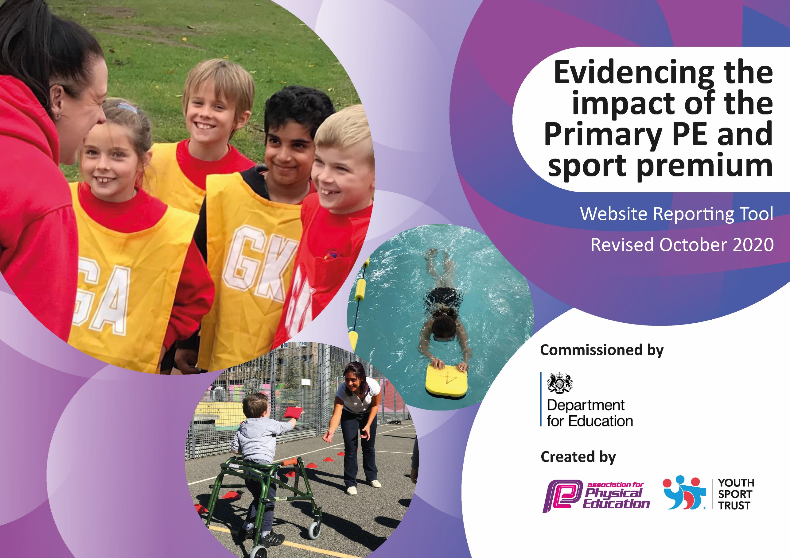
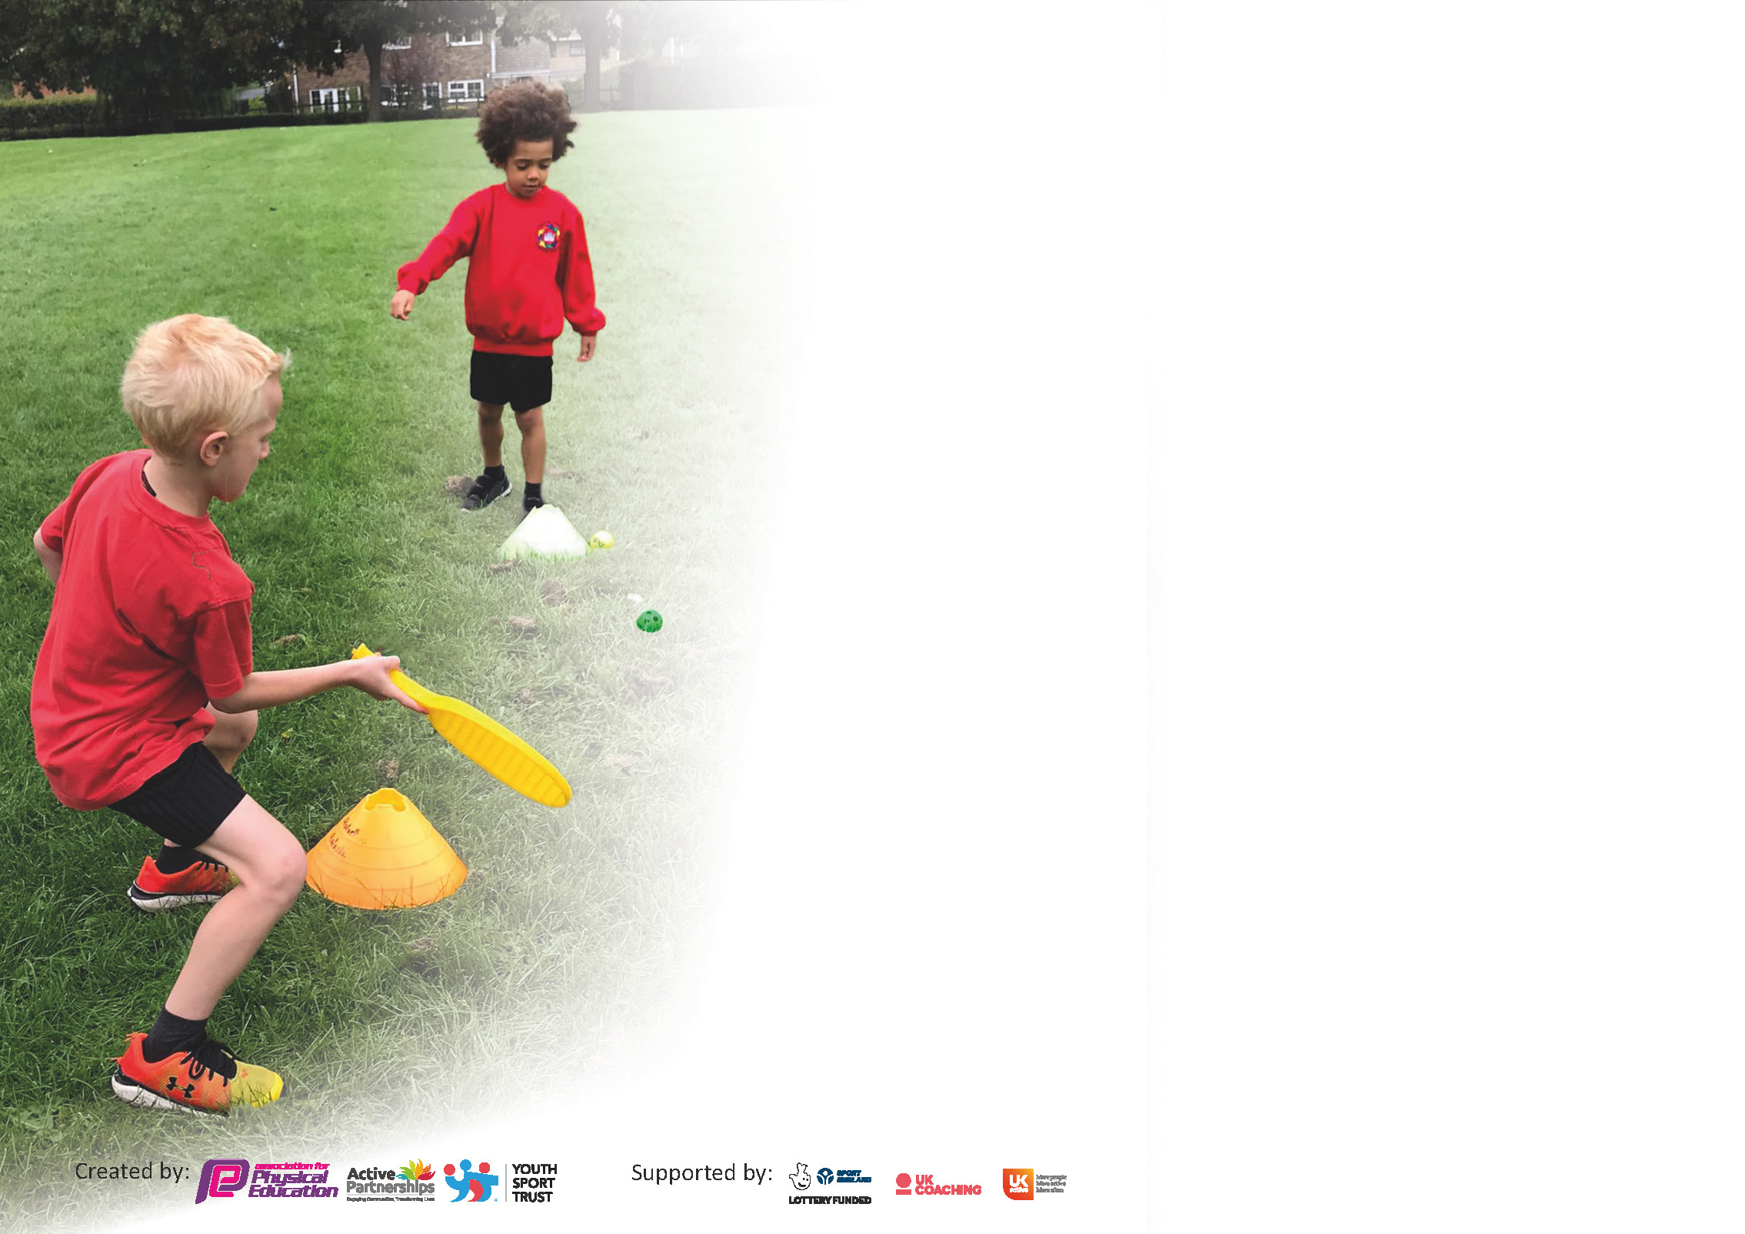

It is important that your grant is used effectively and based on school need. The Education Inspection Framework (Ofsted 2019 p64) makes clear there will be a focus on ‘whether leaders and those responsible for governors all understand their respective roles and perform these in a way that enhances the effectiveness of the school’.

Under the Quality of Education criteria (p41) inspectors consider the extent to which schools can articulate their curriculum (INTENT), construct their curriculum (IMPLEMENTATION) and demonstrate the outcomes which result (IMPACT).

To assist schools with common transferable language this template has been developed to utilise the same three headings which should make your plans easily transferable between working documents.

Schools must use the funding to make additional and sustainable improvements to the quality of Physical Education, School Sport and Physical Activity (PESSPA) they offer. This means that you should use
the Primary PE and sport premium to:

- Develop or add to the PESSPA activities that your school already offer
- Build capacity and capability within the school to ensure that improvements made now will benefit pupils joining the school in future years

Please visit gov.uk for the revised DfE guidance including the 5 key indicators across which schools should demonstrate an improvement. This document will help you to review your
provision and to report your spend. DfE encourages schools to use this template as an effective way of meeting the reporting requirements of the Primary PE and sport premium.

We recommend you start by reflecting on the impact of current provision and reviewing the previous spend.

Schools are required to publish details of how they spend this funding as well as on the impact it has on pupils’ PE and sport participation and attainment by the end of the summer term or by 31st July 2021 at the latest.

** In the case of any under-spend from 2019/20 which has been carried over this must be used and published by 31st March 2021.

We recommend regularly updating the table and publishing it on your website throughout the year. This evidences your ongoing self-evaluation of how you are using the funding to secure maximum, sustainable impact. Final copy must
be posted on your website by the end of the academic year and no later than the 31st July 2021. To see an example of how to complete the table please click HERE.
Created by: Supported by:

Please note: Although there has been considerable disruption in 2020 it is important that you publish details on your website of how you spend the funding - this is a legal requirement.
Support for review and reflection - considering the 5 key indicators from DfE, what development needs are a priority for your setting and your pupils now and why? Use the space below to reflect on previous spend and key achievements and areas for development.

N.B. In this section you should refer to any adjustments you might have made due to Covid-19 and how these will influence further improvement.
Key achievements to date until July 2020: | Areas for further improvement and baseline evidence of need:
- Our children have become more physically active.  - They recognise the important of reflecting our school ethos ‘We Create. We Explore. We Care, We Soar.’ We do this by respecting equipment, themselves and other and by engaging with physical activity daily.  - The children are beginning to use the Daily Mile Track independently during their breaks and lunchtimes, seeing the benefits of physical activity on their health and wellbeing.  - They aspire to achieve their goals and recognise sporting achievements in former members of our schools. | - A more holistic approach to teaching PE, within a framework that provides progression across all year groups and disciplines is needed. This will provide our children with a high standard of taught PE lessons that reflect our ethos in school. By upskilling staff, we provide our children with the best opportunities to become physically educated, active children who have a lifelong passion for maintaining a healthy lifestyle.  - More opportunities for competitive sports need re-establishing in school. This will further enable us to mark pathways for the children to achieve their sporting goals.  - Mental and physical health has clear links to achievement and wellbeing. It is one of our Key Priorities in school this year.  - Outdoor and active learning needs to be evident in our teaching with links to PE as a start point.

Did you carry forward an underspend from 2019-20 academic year into the current academic year? NO

If YES you must complete the following section
If NO, the following section is not applicable to you

Academic Year: September 2020 to March 2021 | Total fund carried over: £ | Date Updated:
What Key indicator(s) are you going to focus on? N/A |  |  |  | Total Carry Over Funding:
 |  |  |  | £
Intent | Implementation |  | Impact
Your school focus should be clear how you want to impact on your pupils. | Make sure your actions to achieve are linked to your intentions: | Carry over funding allocated: | Evidence of impact: How can you measure the impact on your pupils; you may have focussed on the difference that PE, SS & PA have made to pupils re-engagement with school. What has changed?: | Sustainability and suggested next steps and how does this link with the key indicators on which you are focussing this academic year?:
If any funding from the academic year 2019/20 has been carried over you MUST complete the following section. Any carried over funding MUST be spent by 31 March 2021.

Meeting national curriculum requirements for swimming and water safety.

N.B Complete this section to your best ability. For example you might have practised safe self-rescue techniques on dry land.
What percentage of your current Year 6 cohort swim competently, confidently and proficiently over a distance of at least 25 metres?  N.B. Even though your pupils may swim in another year please report on their attainment on leaving primary school at the end of the summer term 2020. | 92 %
What percentage of your current Year 6 cohort use a range of strokes effectively [for example, front crawl, backstroke and breaststroke]? | 60 %
What percentage of your current Year 6 cohort perform safe self-rescue in different water-based situations? | 67%
Schools can choose to use the Primary PE and sport premium to provide additional provision for swimming but this must be for activity over and above the national curriculum requirements. Have you used it in this way? | Yes/No – SLA planned for but did not happen due to Covid restrictions

Action Plan and Budget Tracking
Capture your intended annual spend against the 5 key indicators. Clarify the success criteria and evidence of impact that you intend to measure to evaluate for pupils today and for the future.
Due to Covid resrictions and /or national lockdown/s some planned funding allocations were reduced (Covid Adjustments)
Academic Year: 2020/21 | Total fund allocated: £ 19544 | Date Updated:January’21,
Key indicator 1: The engagement of all pupils in regular physical activity – Chief Medical Officers guidelines recommend that primary school pupils undertake at least 30 minutes of physical activity a day in school Covid Adjustments |  |  |  | Percentage of total allocation:
 |  |  |  | 46% (41%)
Intent | Implementation |  | Impact
What do we want the pupils to know and be able to do? What do they need to learn and to consolidate through practice? | What actions are needed to achieve our intentions? | Funding allocated | What evidence of impact will we look for?  What do pupils now know and what can they now do? What has changed? | How can this be sustained? What are our next steps?
To ensure all children are active for at least 30 minutes per day during planned lunchtime activities.  To ensure children have access to additional physical activity sessions during curriculum time to promote mental and physical health and wellbeing – Daily \Mile  To ensure more children meet the national requirement on leaving Primary school | - Children will be supported to access equipment and activities safely within their class bubble.  - Specialist Coaches will support CSAa to deliver sporting and physical activities to all children during lunchtime sessions to develop skils, knowledge, and a desire to participate regular physical activity.  - Timetabled slots added into curriculum for children to access during brain breaks.  - Flexibility in teaching time to allow for teachers and children to access Daily Mile track when needed to support our children’s mental and physical health and wellbeing  - Y6 pupils who have not met national swimming requirements will access additional swimming lessons in the Summer term | Junior Sports coaches x 2 per day = £8050  No costs involved  £1000 (no cost) | Children will be able to access a range of activities and make activity choices based on their learning.  Children will understand and feel the impact of regular physical activity and therefore realise its’ importance on their mental health and wellbeing by choosing a variety of lunchtime activities.  Children can make informed decisions about activities that promote their mental and physical health and wellbeing.  Increased numbers of Y6 pupils will meet the national curriculum requirements or swimming. | Autumn review – children working in class bubbles with own set of equipment linked to School RA. Coaches delivering support to Children and CSAs across all bubbles.  End of year Review – situation remains the same  Additional PA slots in the timetable included during school closures and were added into timetable to allow for outdoor use of the Daily Mile track. England Does the Daily Mile organised as whole school event and was very successful.  Did not happen - difficulties arranging due to Covid restrictions
 |  | Total Spend: £8050

Key indicator 2: The profile of PESSPA being raised across the school as a tool for whole school improvement  Covid Adjustments |  |  |  | Percentage of total allocation:
 |  |  |  | 7%
Intent | Implementation |  | Impact
What do we want the pupils to know and be able to do? What do they need to learn and to consolidate through practice? | What actions are needed to achieve our intentions? | Funding allocated | What evidence of impact will we look for?  What do pupils now know and what can they now do? What has changed? | How can this be sustained? What are our next steps?
To provide outdoor learning opportunities for KS2 children by linking OAA Orienteering skills and activities in PE to Maths, SPaG, and then in the future, the wider curriculum.  Autumn Review - Phase 1 Staff training of CCO scheme by PE lead postponed linked to School Covid RA  End of year Review – Phases 1-3 postponed linked to School Covid RA (staff to attend remote training within bubbles). Programme of training to be carried forwards into next year. Consider cost implications of delivery by Will Huntington, CCO creator, direct to staff. | Autumn Term Phase 1 –Course Set Up and Training  Cross Curricular Orienteering  Scheme and all contents purchased and course set up in playground. Training delivered to VG PE Lead who will then provide orienteering training and support materials to KS2 staff. Online support made available from CCO.  Spring Term Phase 2 – Children receive PE OAA Orienteering training and begin to use it in lessons.  Staffs deliver orienteering training in their outdoor PE session to equip the children to access the courses. Staff may begin to use Maths and SpaG courses.  Summer Term Phase 3 – Maths and SPaG courses in full use during curriculum teaching. | £1443 to purchase the materials and VG to receive training. | Phase 1 course will be set up and all staff training complete to enable the children to receive the learning.  Phase 2 - children are skilled in the use of orienteering course and can complete the PE course as part of a team with the support of a trained staff member  Phase 3 – Children will be applying their orienteering skills to their learning some areas of the curriculum especially Maths and SPaG  Wellbeing and mental health improved due to exposure to the natural environment. In line with current DfE reopening guidance - pupils learning will take place outside of the classroom as much as possible both within PE and wider lessons. | Cross curricular approach to learning made with clear links to the physical and mental health benefits of outdoor learning.  Learning time outdoors has increased  Active Learning increases which improves engagement and progress for all learners.  Next Steps Phase 4 – 2021/22  Blank course maps used linked to the wider curriculum
 |  | Total Spend: £1443

Key indicator 3: Increased confidence, knowledge and skills of all staff in teaching PE and sport Covid Adjustments |  |  |  |  | Percentage of total allocation:
 |  |  |  |  | 36%
Intent | Implementation |  |  | Impact
What do we want the pupils to know and be able to do? What do they need to learn and to consolidate through practice? | What actions are needed to achieve our intentions? | Funding allocated |  | What evidence of impact will we look for?  What do pupils now know and what can they now do? What has changed? | How can this be sustained? What are our next steps?
To ensure that the children receive high quality physical education that reflects the holistic nature of our approach to learning, staff must have the confidence and skills to deliver high quality physical education lessons  Autumn Review – LTP plans adapted to link to School Covid RA  End of Year Review: Staff have delivered a selected range of units over the year, some restrictions linked to School Covid RA. | PE Lead will have access to up to date and relevant training to support her role in school  MPETT – half termly webinars and links made with PE professionals  YST – half termly webinars chosen to support VG’s development.  Staff in school will have the confidence and skills to deliver high quality physical education lessons through staff training sessions and in house lesson support.  Merton SSP  CITC Georgia (Y1-Y6)  CITC Reiss (YR - YN session not funded through PE&SP) |  | £195  No costs  Full scheme including online access  £1324 + online renewal £73.40  One full day per week - £4995  1 hourly session per week £375 | PE Lead, VG, will have a relevant and more confident understanding of the current issues facing the implementation of PE  She will be upskilled and more able to support staff  Staff will feel more confident to deliver PE lessons by using the new Merton Schemes of work and providing accurate assessments of viewing the children as learners linked to the head, heart, hands philosophy.  Staff will be supported by a trained coach who will demonstrate good practice in delivering high quality PE lessons using the objectives and assessment criteria set out in the Merton SoW. | Teaching high quality PE lessons across the school will have a future impact on levels of attainment evidenced by future assessment data.  Next Steps:  Review assessment format linked to taught units alongside staff.  Continue to share good practice with staff and signpost ways of accessing support from year group colleagues and/or PE Lead.  PE Lead to use available data from the selected taught units as a baseline.  Review coverage linked to future PE direct teaching.
 |  |  | Total Spend: £6962.40

Key indicator 4: Broader experience of a range of sports and activities offered to all pupils Covid Adjustments |  |  |  | Percentage of total allocation:
 |  |  |  | 9% (3% )
Intent | Implementation |  | Impact
What do we want the pupils to know and be able to do? What do they need to learn and to consolidate through practice? | What actions are needed to achieve our intentions? | Funding allocated | What evidence of impact will we look for?  What do pupils now know and what can they now do? What has changed? | How can this be sustained? What are our next steps?
To be able to access after school clubs that are run by trained individuals who have a specialist focus linked to sporting team activities and also activities that promote health and wellbeing.  Autumn Review – Afterschool Clubs postponed linked to School Covid RA  End of Year Review - Afterschool Clubs postponed linked to School Covid RA | Yoginis  VG to undertake training to level 1of the Yoginis Yoga accreditation and then deliver it to groups of children as an after school club  Active Plus  Specialist Coaches deliver sporting activities to children as an after school club with the intention of forming school sports teams which will compete during the Summer Term | £473.50 + yearly renewal £72  £1300 (no cost)  (one session per week, £216.66 per half term) | Children who attend the clubs are introduced to yoga and how it promotes their physical fitness. (Further training focuses on breath and then brain) | Children will then move on to Level 2 Breath once VG has practiced Level 1 Physical for 6 months alongside them.  Teams are established in school and they continue to participate in competitions and build on their successes.  Next Steps:  Clubs to run next year when school RA allows for safe delivery
 |  | Total Spend: £545.50

Key indicator 5: Increased participation in competitive sport Covid Adjustments |  |  |  | Percentage of total allocation:
 |  |  |  | 7% (5% )
Intent | Implementation |  | Impact
What do we want the pupils to know and be able to do? What do they need to learn and to consolidate through practice? | What actions are needed to achieve our intentions? | Funding allocated | What evidence of impact will we look for?  What do pupils now know and what can they now do? What has changed? | How can this be sustained? What are our next steps?
Children will have the opportunity to participate in competitions as part of the Association’s programme of events  Autumn Review – Afterschool Clubs and competitions postponed linked to School Covid RA.  End of Year Review - Afterschool Clubs and competitions postponed linked to School Covid RA. | Manchester Schools PE Association membership paid for.  Competitions linked to previously taught after schools clubs attended by the school’s Basketball and Dodgeball teams  Additional action:  Review virtual competitions provided by Manchester Schools PE to enable children to participate | £900  £500 transport costs (no cost) | Awareness of children’s participation and successes in competitions raised in school. | Future team sports become more established and part of our regular calendar of events for in school and after school activities.  Next Steps:  Competitions run next year when school RA allows for safe travel and participation.
 |  | Total Spend: £900

TOTAL PROJECTED SPEND: £ 20,555.50 ACTUAL SPEND: £ 17,900.90
FUNDING ALLOCATED FROM PRIMARY PE AND SPORTS PREMIUM GRANT: £19, 544 (100 %) £1643.10 underspend to be carried over to the next grant
FUNDING ALLOCATED FROM SCHOOL BUDGET: (0 %)

Signed off by
Head Teacher: | MAUREEN HUGHES | Date: 28/06/21
Subject Leader: | VAL GANNER | Date: 28/06/21
Governor: |  | Date:

