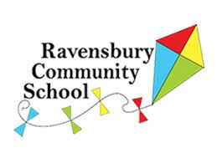

Ravensbury Community School
Connected Curriculum Policy

Written:
Agreed by Governors:
Review Date:

Introduction
This policy sets out the framework for teaching and learning through the Connected Curriculum at Ravensbury Primary School.
INTENT
In adopting this policy the aim for the Connected Curriculum is to:
- Maximise the quality of teaching and learning at the school.
- Achieve high quality teaching of Arts and Humanities
- Include varied and numerous opportunities for application of basic Numeracy, English and Computing skills through real ,practical and exciting challenges
- Develop critical thinking skills such as analysing, synthesising and creating.
- Provide opportunities to work in collaboration with other children
- Give pupils the opportunity to present work to varied audiences in a number of different formats
- Develop Oracy and communication skills
- Extend and broaden children’s learning and interests within the Connected Curriculum
- Give children the opportunity to apply the skills, understanding and knowledge in a real life situation
- Widen vocabulary understanding and use through the use of tiered language teaching
Teaching and Learning
The Connected Curriculum will be taught across the school. Although the Foundation stage will not be expected to follow the same planning and delivery process as Years 1 -6, the aims of their curriculum will be the same. (Please see Aims)
Why teach through the Connected Curriculum?
- We believe that children who experience our Connected Curriculum will be able to make connections between themselves, their community and the wider world. In developing skills, taking part in meaningful and exciting experiences, our children will develop their self- confidence, their self- identity and feel a sense of success and achievement.
- We hope our Connected Curriculum will nurture the roots of life- long learning and embed a thirst for discovery about the world beyond the immediate. We hope the experiences will foster a positive approach to life and its future challenges and raise the aspirations of all our children.
- The experiences are designed to stimulate creativity and allow the children to apply the skills, understanding and knowledge they have learnt. Experiences offered to the children should be practical, real and memorable.
- Skills, both subject specific and cross curricular, need to be explicitly taught to the children. They should be developed within the context they need to be used.

IMPLEMENTATION
How will we teach the Connected Curriculum at Ravensbury Community School?
Please see Appendix : Success Criteria for teaching the Connected Curriculum.
When will we teach the Connected Curriculum?
The Connected Curriculum will be in addition to Numeracy, English, Science, PHSE, Spanish and Computing. It will usually encompass the Arts and Humanities and can include RE ,PE and Science when appropriate. The Connected Curriculum will take approximately 2 – 4 hours each week .

Assessment for Learning
Teachers and children will follow the school’s current assessment systems to ensure that progress is being made across the Connected Curriculum. Assessment opportunities will be built into each Connected Curriculum lesson for both the child to assess themselves and the teacher to assess the progress made by each child. This will be in the form of a ‘Can I ‘ question which will be taken from the National Curriculum objectives .
Summative assessment will also be made by each class teacher using the Can I statements for each subject.
Access to the curriculum
All children at Ravensbury will learn through the Connected Curriculum. Children who need support to access teaching and learning will be given appropriate provision matched to his/her need (s) . (Please see Teaching and Learning , EAL policy, SEND policy, Behaviour policy.)

Roles and responsibilities
The Headteacher, Maureen Hughes , has overall responsibility for the Connected Curriculum provision.
The teacher currently responsible for the Connected Curriculum provision across the school is Sarah Harriott and the teacher responsible for the management and leadership of the subject leaders is Jo Wendt.
Joanne Wendt will :
- Work with all foundation subject leaders to ensure the coverage, progression and assessment of and within each foundation subject across the school.

Sarah Harriott will:
- Work with the Senior Leadership Team to monitor standards of Connected Curriculum teaching and learning across school including planning and books.
- Work with English and Maths leads to ensure application of competencies during Connected Curriculum lessons such as Numeracy, Computing and Literacy .
- Liaise with class teachers to support the planning and development of the Connected Curriculum.
Class teachers are responsible for the provision of the Connected Curriculum in his/her class.
Teaching assistants can be directed by teachers to deliver provision. However, teachers still remain responsible for the child’s provision and progress.
Monitoring and review
This policy will be reviewed by the governors and will be reviewed in two years, or earlier if necessary.

IMPACT
Appendix
Success Criteria for CC planning
Use overview to plan objectives and for the title question
- ‘Driver’ or main subject area leading the content: History, Geography, Science and /or D and T.
- Enhancers (other subject areas) : Music, Art, D and T and RE.
- An experience at the end of the unit
This will include:
- An innovative purpose eg a performance, an exhibition, mantle of the expert, manufacturing/financial project etc.
- A specific audience eg another class, parents, staff, the whole school , another school, the community , a school in another country via the internet etc.
- An activity which allows the children to apply the skills and knowledge they have learnt in a creative way to demonstrate what they have learnt.

✔ Assessment of knowledge and skills before and after each unit of work using the National Curriculum learning objectives

✔ A focus on spoken language skills eg vocabulary developing, fluency, articulation

✔ Cross curricular work (Science can be taught as a stand - alone subject where necessary)

✔ Personal, Learning and Thinking Skills eg collaborative learning or leadership skills to
develop Social Moral Spiritual and Cultural understanding.

✔ Planned opportunities for depths of learning

✔ Direct teaching of curriculum skills
✔ The use of active and collaborative questioning
✔ A ‘creative‘ approach to teaching and learning using the depths approach

Success Criteria for Connected Curriculum books
Key | Evidence in the books | Mostly evidenced in the books | No evidence in the books

Pre learning assessment: KWL grid or mind map with the half term’s question as a stimulus
High standards of presentation including joined writing where appropriate
Children’s independent skills
Creative techniques to display work in books
Support given across the year group to ensure parity of presentation and depth of content covered is the same or very similar in both classes.
Photographs showing the launch, experiences or activities which are not recorded on paper eg Mayan games in PE, visit to Pizza express, drama
Children writing captions/titles for photographs /diagrams
Application of basic skills:
• Evidence of reading for specific purposes
• Writing
• Mathematics and Computing
• All written work shows the correct use of age related basic skills eg correct use
of capital letters and full stops / question marks etc.

Evidence of depths of opportunity offered to the children to extend the children’s knowledge, understanding and skill across the unit not within each lesson
Teaching and learning sequence includes elements of:
- diversity (race, gender,sexuality, culture, age, disability, religion or belief)
- role models /aspirations and aspirational people from around the world and from different sectors of society
- climate change and environmental issues
Evidence of the experience with an audience and creative and innovative opportunities
Evidence of the children’s response to the work: ragged response to learning objective (traffic lights)
A reflective session at the end of the unit of work (golden question)
Evidence of the teacher’s response to work: post learning assessment using National curriculum objectives for each piece of work . (Traffic lights )
Evidence of active and collaborative questioning promoting SMSC

Quick check list for CC learning process at
Ravensbury Community School

Title for each unit of work is a question.
(Questions can be found on the overview for your year group. Teachers 🡪Staff drive 🡪 Connected Curriculum🡪 Overview

Planning mapping out the teaching and learning sequence

Pre learning assessment :
KWL grid (what I know/what I wonder/would like to know/ what I have learnt ) or mind map using the question for your CC unit of work .

Launch: a short session to introduce the children to the unit of work.

Evidence of tier 2 and 3 vocabulary being taught.

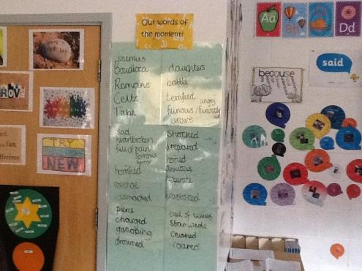
Evidence to demonstrate children’s learning (objectives taken from the CC overview document and medium term plans on the Google staff drive).
This can be:
Children’s work
Photos of activities the children have done with captions or explanations written by the children.
Evidence of depths offered to the children across each unit of work.
Evidence of diversity and/or climate and environmental issues across the unit of work.

At least one or two creative ways to display work.

Each piece of work has the Can I …taken from the National Curriculum and a ‘traffic light’ assessment . (Or a Can I contents page )

Can I … |  | I understand the learning.
 |  | I understand some of this.
 |  | I do not understand.

Evidence of the experience at the end of the unit of work which shows innovation and creativity.
Audience for the experience
A range of experiences across the year :
Performance
Exhibition
Entrepreneurial venture
Innovation
Digital
Citizenship / community

A golden question which promotes a range of Social Moral Spiritual and Cultural thinking across the year.
Children’s response to the golden question.

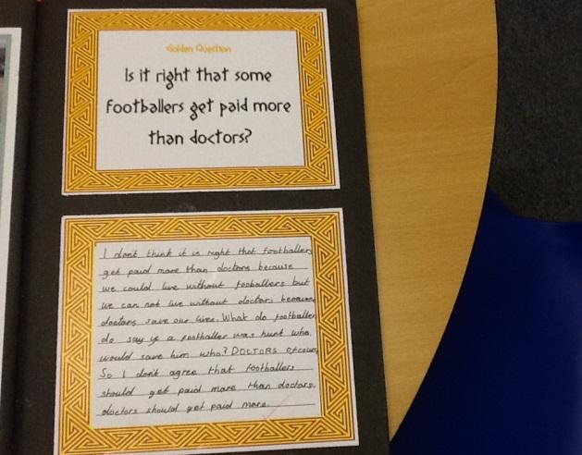
Teacher and child tick the traffic light assessment for each learning objective covered.

Children fill in the ‘what I have learnt ‘ section of the KWL grid (at the front of the book in purple).

What is an Experience?

The Experience is the end result of all the work covered with the children over the half term:

- It is a real life application of the skills and knowledge taught throughout the CC unit or one part of your unit of work.
- An opportunity for children to use creativity and innovation
- It needs to have a purpose and an audience
- The Experience is not a trip or a visitor.
- An opportunity to foster skills for life in the modern world.

Type of experience |  | Example
Performance | Performing to an audience | - Assembly  - A Midsummer Night’s Dream William Shakespeare rap
Exhibition | Displaying information or Art etc to an audience to inform | - William Morris exhibition  - Local wildlife exhibition
Entrepreneurial | Making money | - Making purses to sell at the Christmas fair to raise money for the school.  - Making and selling cakes to raise money for Water Aid.
Innovation / team work /leadership | A team project to create something new using the skills taught through the CC unit. | - Building a shelter to survive on an island  - Making a Chinese dragon and doing a dragon dance  - Rock quiz for another year group
Digital | Using technology to communicate or design record | - Making an information leaflet on the Great Fire of London.  - A travel brochure for Greece.
Citizenship / community | An event in the local community | - Performing to a nursery  - Healthy food café for parents

