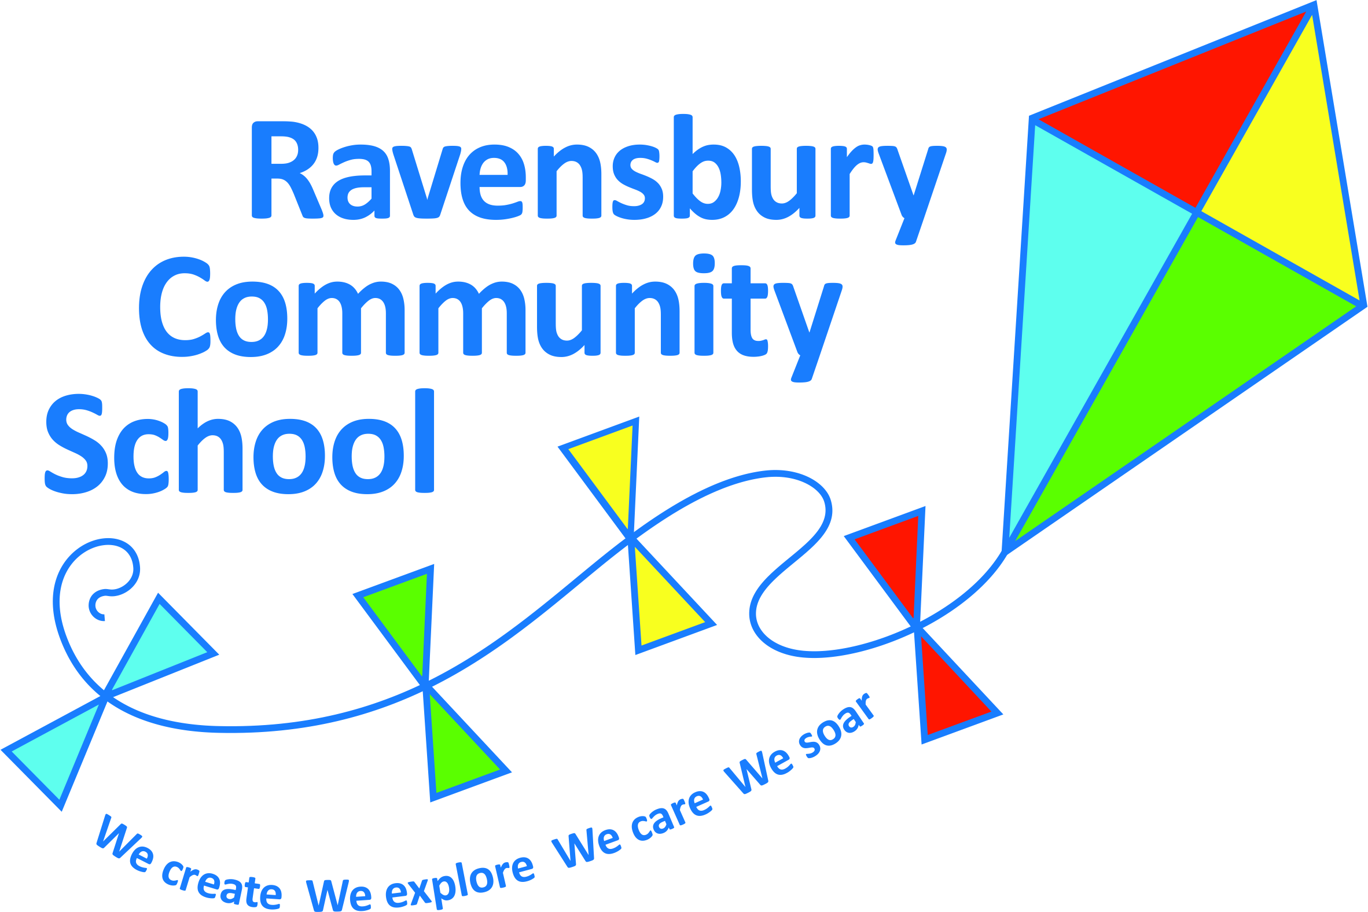
Ravensbury Community School
Y5 Connected Curriculum Overview

Year 5 | Key Texts – link to English | History | Geography | Art | Design Technology | Experience and Golden Question
Autumn 1  What did the Victorians do for us? | Oliver Twist  Hard Times | UK history  Victorian Britain – Exploration and Discovery and Childhood study.  A study of an aspect of history (IR) dating from a period beyond 1066 that is significant in the locality.  Local History study – Industrial Revolution |  | William Morris Textiles and Digital Media  To use a range of materials creatively to design and make products. To learn about the work of a designer (William Morris), describing the differences and similarities between Industrial Britain and the Arts and Crafts Movement, making links to their own work. |  | Is it right that children were paid less than adults for doing the same work in factories?
Autumn 2  Why does the world need great inventions? | Bridge to Terabithia  Narnia Series  100 Inventions that Changed the World |  | How has the human geography of Manchester been used to promote economic activity and trade links between regions of the UK and beyond?  Use of canals and rivers – link to bridges |  | Structures – building an opening bridge  Understand and use mechanical systems, linkages, cams and levers.  Generate, develop and explain ideas through cross-sectional and exploded diagrams. | Do all inventions have a positive impact?
Spring 1  Why is Dina Asher-Smith famous? | The 12 Labours of Heracles  The First Olympics | World History  Ancient Greece – A study of Greek life and achievements and their influence on the western world – Olympic Games  Theme in British history: Legacy of Greek culture on Britain |  |  | Sculpture (shaping)  Making a Greek relief tile representing one of the Ancient Olympics events.  Select from a wider range of shaping tools and equipment to perform a practical task – e.g. Greek tile. | Is it right that some sportspeople get paid more than doctors?
Spring 2  What is it like to live in Greece? | A Midsummer Night’s Dream  Non-Fiction texts about Greece |  | Locate countries of Europe, with a specific focus on Greece. Name and locate key topographical features of a Greek coast and understand how some of these aspects change over time.  Key aspects of human geography including types of settlement and land use, economic activity including trade links and the distribution of natural resources including energy, minerals, food and water.  Compare human and physical geographies with the UK coastline ( Blackpool from Y4) . | Drawing /Art civilization Greek pastel – Nikolas Georgoudakis  To improve the mastery of art and design techniques with a range of materials. |  | Should countries be made to accept refugees?
Summer 1  What’s in an astronaut’s suitcase? | Blue Planet  Footprints on the Moon | Changes in an aspect of social history: Changes in an aspect of social history from Victorian travel and transport to current day (revisit Victorian KS1 work around flight) including space travel. |  |  | Nutrition  Understand and apply the principles of a healthy and varied diet to fit with the needs of an astronaut.  Research other people’s design for nutrition in space and adapt for my own design. | Is there something bigger than the universe?
Summer2  Why is Spain such a popular tourist destination? | Toro! Toro!  The Bullfight  Non-Fiction texts about Spain |  | Identify the environmental regions of Spain including key physical and human characteristics.  Describe and understand the key aspects of physical geography including identifying Spain’s climate zone, biomes and vegetation belts.  Key aspects of human geography including types of settlement and land use, economic activity including trade links and the distribution of natural resources including energy, minerals, food and water.  Compare human and physical geographies with the UK. | Painting /  Artist focus  Innovating and experimentation.  Learn about the work of Picasso.  Picasso (link to Gaudi’s Guell Park and Sagrada Familia)  Pupils should be taught about great architects and designers in history – Gaudi, Dali |  | Should bull fighting be banned?

