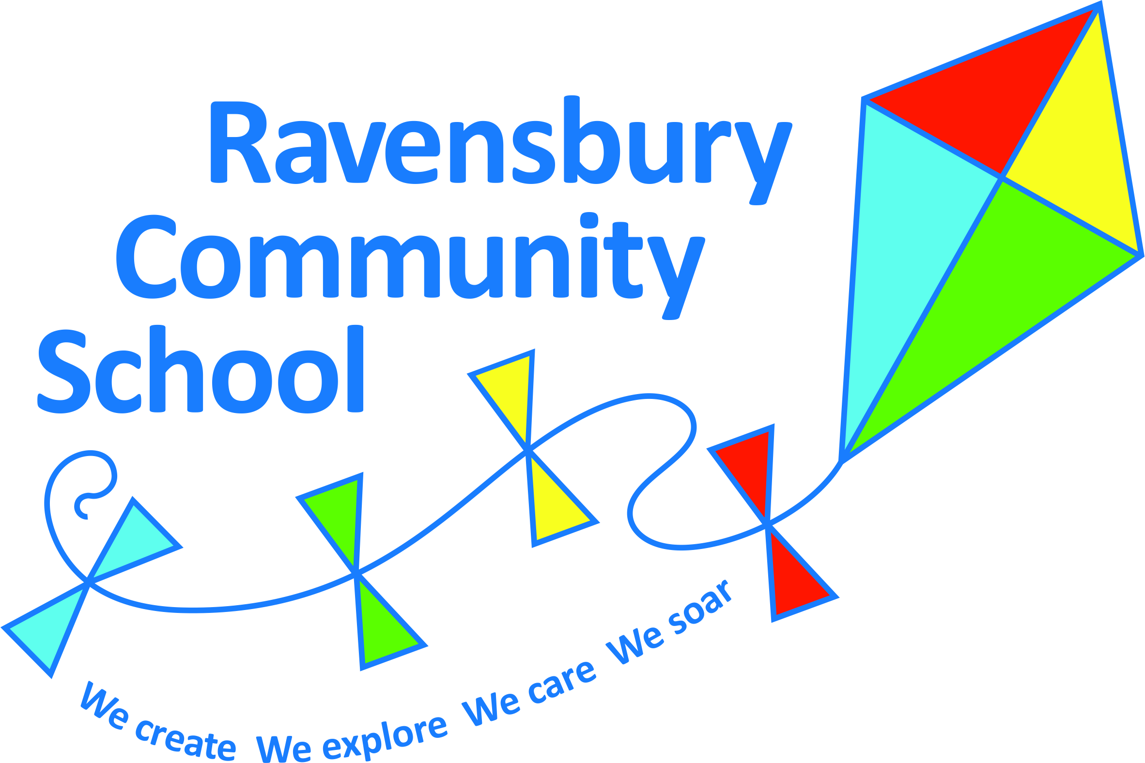
Ravensbury Community School
Y4 Connected Curriculum Overview

Year 4 | Key Texts – link to English | History | Geography | Art | Design Technology | Experience and Golden Question
Autumn 1  The Mayans: What can they teach us? | The Hero Twins | World History: Study a non-European society that provides a contrast with British History covered so far. Changes in social structure.  Mayan Civilization c. AD 900 |  |  | Nutrition: Understand seasonality and know where and how a variety of ingredients are grown, reared and processed.  Making Tortillas using products which are in season and/or locally sourced. | Do you share the same views about social class as the Mayans?
Autumn 2  What is there in North America? | I survived  The Earth Dragon |  | North America: California - Mountains and Earthquakes  Using maps, locate the countries within North America; the mountainous regions of the State of California. Identify the key physical characteristics of a mountain range.  Locate the key physical and human characteristics of the USA and the city of San Francisco.  Describe and understand the key characteristics of Earthquakes. | Elaine Sturtevant  Printing  To learn about great artists and make links to own work.  To improve the mastery of art techniques using a range of materials.  To develop a range of art and design techniques in colour, pattern and line. |  | Is there a safe place in California to live?
Spring 1  How would we survive without water? | The Water Horse |  | Describe and understand the key aspects of Rivers and the Water Cycle; including the distribution of natural resources of water.  UK River study: use fieldwork to observe, measure, record rainfall over a period of time using a rain gauge  Observe the physical features of a river using maps, digital photography, atlases and aerial photographs. | Monet – water painting  To learn about great artists and make links to own work.  To improve the mastery of art techniques using a range of materials.  To develop a range of art and design techniques for painting, in colour, texture, form and space. |  | Should we donate money to provide clean water for people in other countries?
Spring 2  Why did the Anglo Saxons and Vikings Invade? | Beowulf  How to be an Anglo Saxon in 13 easy stages | British History: Britain’s Settlements by the Anglo-Saxons and Scots.  Anglo-Saxon invasion, settlements and kingdoms in particular life of the child |  |  | Textiles: Anglo-Saxon weaving  To select from a wider range of tools to make own loom to perform practical tasks i.e. weaving - cardboard loom and wool weft and warp.  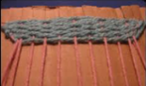 | Is it ever right to invade other countries and make their land your own?
Summer 1  How is Castleton different from Clayton? | Room 13  Countryside verses Town life |  | Name geographical regions and identify human and physical characteristics (Peak District National Park). Castleton vs Clayton  Identify key topographical features including hills, mountains, and rivers (River Noe). Identify land use patterns and how some of these aspects have changed over time.  Complete a traffic survey, land use survey and locality sketch for each area. | Castleton – collage  To use a range of materials to design, create and make a collage. |  | Do you think tourism effects the environment?
Summer 2  Who would win in a battle; Anglo-Saxons or Vikings? | Norse Myths  How to train your Dragon | The Viking and Anglo-Saxon struggle for the Kingdom of England to 1066: Exploration and Discovery  Viking raids and invasion, Anglo-Saxon laws and justice. |  |  | Viking Longboats –  Design a Long Boat including a gear or pulley in order to raise a sail which will help the boat move faster.  To understand gears and pulley. | Would you have the courage to cross the sea in a Viking Long Boat?

